**VIETNAM NATIONAL UNIVERSITY HO CHI MINH CITY  
UNIVERSITY OF INFORMATION TECHNOLOGY  
FACULTY OF INFORMATION SYSTEMS**



**CAPSTONE PROJECT FINAL REPORT**

**INFORMATION SYSTEM ANALYSIS AND DESIGN**

**ELECTRONIC WEBSITE**

**INSTRUCTORS:**

PhD. Cao Thi Nhan

MS. Duong Phi Long

**GROUP MEMBERS:**

Nguyen Trong Nhan – 19521940

Nguyen Hoang Thang – 19520949

Nguyen Quoc Khanh – 20521452

Nguyen Minh Khoi – 20521479

**THANK YOU**

**INSTRUCTOR CRITIQUE**

TABLE OF CONTENTS

1. Introduction 7

1.1 Overview 7

1.2 Solution 8

1.3 Project Objectives 8

1.4 Scope of project/ Limitations of study 8

1.5 Developer tools & Technology 9

2. Requirement Specification 10

2.1 Situation survey/ Survey of current situation 10

2.1.1 Interview 10

2.1.1 Survey of the organization/ Current organizational situation 20

2.1.2 Survey of business processes, major activities 20

2.2 Software requirement 24

2.2.1 Functional requirements 24

2.2.2 Non-functional requirements 26

3. Analysis and design 27

3.1 Use-case diagram 27

3.1.1 List of actors 28

3.1.2 List of use-case 29

3.2 Use-case specification and activity diagram 31

3.2.1 Sign in 31

3.2.2 Sign up 33

3.2.3 Use-case manage cart 37

3.2.4 Use-case manage account 41

3.2.5 Use-case purchase 44

3.2.6 Use-case manage transaction history 48

3.2.7 Use-case order tracking 50

3.2.8 Return and refund policy 52

3.2.9 Notification 54

3.2.10 User management 56

3.2.11 Order management 62

3.2.12 Item management 66

3.2.13 Sales partner management 74

3.2.14 Tracking transaction history 81

3.3 Sequence diagram and Class diagram 84

3.3.1 Sign in 84

3.3.2 Sign up 85

3.3.3 Manage cart 86

3.3.4 Manage account 90

3.3.5 Purchase 91

3.3.6 Tracking transaction history 93

3.3.7 Tracking order 95

3.3.8 Return and refund policy 96

3.3.9 Notification 97

3.3.10 User management 98

3.3.11 Order management 103

3.3.12 Item management 107

3.3.13 Sales partner management 113

3.3.14 Tracking transaction history 118

3.4 Class diagram in general and Entity Class diagram 120

3.4.1 User 120

3.4.2 Admin 121

3.4.3 Entity class diagram 122

3.4.4 Class diagram specification 123

3.5 State diagram 148

3.5.1 Account 148

3.5.2 Product 149

3.5.3 Order tracking 150

3.6 Mapping to Relational Model diagram from Entity class diagram 151

4. Implementation and Testing 152

4.1 Introduction to the implementation environment 152

4.1.1 Development environment 152

4.1.2 Deployment environment 152

4.2 User Interface 153

4.2.1 User 153

4.2.2 Admin 161

# Introduction

## Overview

In recent years, E-commerce has been very popular. We can have an office or a shop, which oversees all business operations and the distribution of products to customers. However, we want to find ways to increase our sales quicker, reduce business operating costs and increase profit margins for our business, an E-commerce website is an effective way for us.

The Internet is a powerful platform providing a broad awareness of E-commerce websites. There are millions of people searching the internet everyday, looking for products and services. Online shopping is increasing year-on-year and is being seen as a convenient method to purchase products, where customers can also buy at any time in the day.

Additionally, E-commerce websites allow us to employ a range of marketing and sales techniques to give people that extra reason to stay on our website and buy our products.

The cost of setting up an E-commerce website is lower than an offline business one. The whole sales system for our business is automated online. Therefore, we will save on staff, wages, and other business costs, which are usually an expense such as electricity and rental costs. Our website will also help you expand your product offering faster than is normally possible within an offline business situation. We can increase revenue fast through special offers and online marketing initiatives.

Once our E-commerce website has been set up, we should not invest too much time into running it. This is because the entire process for customers ordering and making payments will all be activated through the online system. This will give us more time to determine new products we want to sell, exclusive offers we want to launch and to track how successful our sales are. We will also be able to determine any trends in terms of which products are selling most successfully.

## Solution

As students studying information technology, we are knowledgeable about technology. So, in this project, we decided to make a website to sell technology products. It will help customers not to spend too much time going to the stores.

Online shops give us the opportunity to shop 24/7 and reward us with a 'no pollution' shopping experience. There is no better place to buy informational products like e-books, which are available to you instantly, as soon as the payment goes through. Downloadable items purchased online eliminate the need for any physical materials at all, as well, which helps the environment!

## Project Objectives

Built a complete sales website system, meeting the basic requirements of customers. Improve skills in information system analysis and design in accordance with organizational requirements, as well as teamwork, communication, information search, and report writing.

Develop programming thinking skills, as well as proficiency with programming methodologies and techniques. Know how to organize a project and practice managing, monitoring, and executing the project.

Complete the course of information system analysis and design, meeting the output standards of the course.

## Scope of project/ Limitations of study

Because of limitations about time, human, our teams focus to some main features include:

* Customer Management.
* Product & Category Management.
* News, promotion management.
* Commercial transaction: ordering, payment.
* Retrieval information.
* Feedback and support management.

## Developer tools & Technology

* Visual studio for IDE.
* Git/ GitHub for version-control.
* Adobe Photoshop and Figma for UX/UI.
* MSSQL for Database Management System.
* ASP.NET Core MVC Framework for building web apps and APIs using the Model-View-Controller design pattern.

# Requirement Specification

## Situation survey/ Survey of current situation

### Interview

|  |  |  |  |  |
| --- | --- | --- | --- | --- |
| **General survey**  System: TGDD, GEARVN, FPT Shop  Creator: Nguyen Trong Nhan Created Date: 28/10/2022 | | | | |
| **Ord** | **Topic** | **Requirement** | **Start** | **End** |
| 1 | Product management | Discover more specifically about a product's lifetime, cost, and its supplier. | 28/10/2022 | 28/10/2022 |
| 2 | Sale report analysis | Manage sales reports on quantity of products sold customer number has been sold to. | 28/10/2022 | 28/10/2022 |
| 3 | Customer management | Techniques for managing customers to improve experiences and offerings. | 28/10/2022 | 28/10/2022 |
| 4 | News, promotion management | Get plans to control promotions as well as intended promotions. | 28/10/2022 | 28/10/2022 |
| 5 | Inventory status | Strategy to control inventory status, such as how stock be handled, if there is enough space for importing, or whether there are enough items available for sale. | 28/10/2022 | 28/10/2022 |
| 6 | Payment management | Organize payment method and its suppliers’ service. | 28/10/2022 | 28/10/2022 |
| 7 | Policy management | Ways to make plan, organize, and control the operations of the basic elements of customers, materials, machines, methods, money, and markets. | 28/10/2022 | 28/10/2022 |

*Table 1. Survey strategy*

|  |  |
| --- | --- |
| **Survey Forms**  System: GEARVN | |
| Interviewee: Nguyen Quoc Khanh | Interviewer: Nguyen Trong Nhan |
| Place: GEARVN Thu Duc | Start: 16:00 pm 28/10/2022  End: 20:00 pm 28/10/2022 |
| Target: gather and comprehend how a particular technological sell works. |  |
| Details of the interview:   * Introduction * Overview about the current system * Survey plan: * Topic 1: Product management. * Topic 2: Sale report analysis * Topic 3: Customer management. * Topic 4: News, promotion management. * Topic 5: Inventory status. * Topic 6: Payment management. * Topic 7: Policy management | Estimated time:   * 5 mins * 10 mins * 50 mins |
| Generals observe |  |
| Unexpected occurrence |  |

*Table 2. Survey Forms*

|  |  |  |
| --- | --- | --- |
| Interviewee: Nguyen Quoc Khanh | | 28/10/2022 |
| Questions | | Records |
| Topic 1 | What is the product’s goal? | Bring up what customers need not just what they want, save their time, money and keep their systems secure. |
| Which are the target markets of these products? | On the consumer market, such as cash-strapped college students, family, and business markets. |
| What criteria are used to evaluate a product? | Often on potential market size, potential demand, and the quality of that product. |
| Topic 2 | How often do you update your analysis to figure out How many product categories are sold? | The statistics of product categories sales will be collected once a week or every two weeks and for a term specified or more frequently than that isn’t always necessary unless there are major changes in sales numbers or other metrics. |
| What type of statistics does the system need to collect on a regular basis? | The system includes the following statistics:   * Statistics of products sold by each category, SKU, vendor, point-of-sale (POS), channel or traffic referrer. * Statistics of top online store searches to identify what people search for the most within the store. * Statistics of finances summary to summarize sales, payments, liabilities, and gross profit data. |
| Topic 3 | How to manage customers? | 5 ways to manage customers:   * Spend More Time with Customers * Send Out a Newsletter Regularly * Use Customer Relationship Management Software * Send Out Surveys * Send Out Incentives |
| What should you do when a customer complains? | Your procedure could include the following steps:   1. Listen to the complaint. Thank the customer for bringing the matter to your attention. ... 2. Record details of the complaint. ... 3. Get all the facts. ... 4. Discuss options for fixing the problem. ... 5. Act quickly. ... 6. Keep your promises. ... 7. Follow up. |
| What are the difficulties when managing customers? | * Customer information data is scattered * Information is not updated in time * Difficulty in tracking and managing employees * Not fully exploiting potential customer data * Customer feedback is forgotten or omitted |
| Topic 4 | How long does the promotion last? | The promotion takes place on public holiday such as noel,8/3...and last until the end of the holiday. |
| Programmer Term and Condition | Here is some popular promotion   * Only applied for new customers * Eligible client will be notified to client through email/SMS to register * The promotion is not combined with any other acquisition campaign running at the same period. |
| How should news be updated? | News must be regularly so that customers can easily be up to date |
| Topic 5 | How to manage inventory effectively? | * Fine-tune your forecasting. ... * Use the FIFO approach (first in, first out). ... * Identify low-turn stock. ... * Periodic inventory of goods * Applying information technology to inventory management |
| What do you do with old inventory? | 1. Refresh, promote and resell products 2. Applying promotion with old inventory 3. Use inventory as giveaways or incentives |
| What are the difficulties in inventory management? | 4 difficulties easily encountered:   * Data saving * Ensure inventory levels * Arrange goods * Outdated equipment / technology |
| Topic 6 | What kind of payment method system accepts? | The system accepts the default payment method which is cash. In addition, the system also supports alternative payment methods not involving credit cards, such as online wallets (Momo or PayPal for example) and bank transfers. |
| Does your system have a refund policy and what are the conditions for implementing it? | We offer refund and/or exchange within the first 30 days of your purchase, if 30 days have passed since your purchase, you will not be offered a refund and/or exchange of any kind. |
| Does your system have an installment policy? | Yes, of course. We always want our customers to have many payment options and comfortable shopping on our system. |
| Topic 7 | What is the current return policy, installment policy and warranty policy of the system? | * About the return policy, products can be returned within 30 days of receipt of shipment. * Installment policies include no-credit-check loans, mortgages, and auto loans. * For warranty policy, customers can exchange one for one, if the item is broken not by customers, but technology. |
| What might be the unintended negative consequences of the policy? | * Customers take advantage of policy loopholes to do bad things for businesses. * Facing litigation and negative public perception. |
| How to make a policy way correctly? | * Keep your policy short, not every detail should be included in the policy, except if it is a complex process that needs a ton of details. * Ensure that your policy is in line with the law to avoid legal issues arising. Your policy should not put the management and employees at risk or in danger. * Keep the end goal in mind, consider why you're writing your new policies, and let that inform the actual writing process. |

### Survey of the organization/ Current organizational situation

### Survey of business processes, major activities

#### Business department

The functional diversity of the business department requires coordination among team members. A typical business department will include sales staff, sales managers, sales managers, sales representatives, sales managers, and related positions.

All members of the sales department work to ensure that sales targets are met. The function of the business department

The business department has the role of bring the company's products and services to the market, and the business department must report it to the Board of Directors. At the same time, the department also researches, surveys, gives opinions and strategies to increase business efficiency.

One of the most essential functions of the business department is to develop a customer base for the company. This function includes taking care of existing customers and expanding the list of new customers for the business.

All business activities and processes going on in the business need to be follow by the business department. After that, the department will make reports in accordance with regulations and send them to the Board of Directors to provide appropriate operational directions for each period.

Mission of business department:

* Research and develop strategies to access the market, attract customers, maintain, and expand relationships with customers.
* Make detailed plans on business activities, including processes, production progress, quality and quantity of goods sources, team allocation.
* Set up information, documents, product quotes to work with customers.
* Research and develop new products to suit market trends and needs.
* Propose to the marketing department strategies and solutions to enhance business efficiency.

#### Human Department

**Store manager**

This is the most prominent position, usually in online shops the store owner is often also the manager position

Store manager is responsible for managing the entire business of the store, recruiting personnel, working with suppliers to plan the import of goods. In addition, the store manager must report the operation and sales to the store owner.

In the era of information technology development, we have used sales management software in our operations. With automatic sales reporting feature helps store owners and managers always capture store sales.

**Salesperson**

As the people who directly consult and sell, responsible for sales. In addition, sales staff also perform after-sales customer care.

Salespeople do well when they are motivated and have good skills. Therefore, to improve the working efficiency of sales staff, store owners should have a reward policy as well as major training programs to improve staff qualifications and skills.

**Marketing staff**

The advantage of an online sales channel is that it can actively search for customers, instead of passively waiting for customers to come like traditional sales. And the job of the marketing department is to find customers through online channels such as SEO, Fan page, Advertising.

The job of marketing staff is to plan marketing, deploy marketing channels and collect customer information. Two important factors are the number of customers to reach and the information of customers. The number of customers to reach and the number of customers to buy from a salesperson are two different goals.

The marketing department has an important role in online sales, with small-scale shops and limited resources, shop owners can hire marketing services.

**Warehouse staff**

Warehouse staff are responsible for managing goods according to orders, controlling delivery deadlines.

Fast and convenient ordering, payment and shipping processes are also important factors in an online business.

#### Technology Department

**System management & development business**: Monitor the performance of system and ready to interface if any anomalous signal found. Considering customer needs for preparation to improve performance of exists system, provide new feature, release documentation.

**System management process:**

* Tracking all information about traffic, request, database.
* Ready to interface when anomalous event occurs.
* Quality control before update system.
* Scaling database, caching.
* System development process:
* Collect customers’ needs from marketing department.
* Consider upgrading system to fulfil customers’ need with new features.
* Source code management.
* Development & operations integrated.
* Continuous Development and continuous delivery.

#### Accountant

Store owner or store manager will concurrently hold the position of accountant. To save human costs and be more proactive in management, especially in business management, shop owners now tend to apply sales management software. With each sales transaction, sales, debt are automatically updated, and goods are automatically deducted from inventory, store owners can fully grasp the data quickly and accurately.

## Software requirement

### Functional requirements

|  |  |
| --- | --- |
| ***No.*** | ***Feature*** |
| 1. | Login |
| 2. | Logout |
| 3. | Insert new item |
| 4. | Delete item |
| 5. | Update item information |
| 6. | Item search |
| 7. | Create order |
| 8. | Insert item category |
| 9. | Update item catalog information |
| 10. | Delete item category |
| 11. | Insert voucher |
| 12. | View inventory list |
| 13. | Manage inventory receipts |
| 14. | Statistic |
| 15. | Promotion Information |
| 16. | Customer support |

*Table 1. Admin function request table*

|  |  |
| --- | --- |
| 1. | Register a new account |
| 2. | Login |
| 3. | Sign up |
| 4. | Add item to cart |
| 5. | Delete the item from the cart |
| 6. | Item search |
| 7. | Apply vouchers to get products discount |
| 8. | View placed orders |
| 9. | View policies (Installment, exchange, warranty...) |
| 10. | Item catalog management |
| 11. | Human Resource Management |
| 12. | View general news |

*Table 2. User functional requirements table*

### Non-functional requirements

1. Quality requirements:

* Update - development:
* Easily upgrade or increase other utility features.
* System maintenance.
* Convenience:

1. There are precise specifications and instructions. Easy to operate.
2. The item description is specific, easy to see, and easy to understand.
3. Stable, reliable operation.

* Compatibility:

1. Works well on all popular media today.
2. Responsive according to different screen sizes.
3. Interface requirements:

* Good-looking.
* User easy to use.
* Clear and detailed display of information.
* Consistency.

# Analysis and design

## Use-case diagram

### List of actors

|  |  |  |
| --- | --- | --- |
| **No.** | **Actor** | **Meaning** |
| 1. | Administrator | As a system administrator, you can manage item, track orders of customer and other selling functions |
| 2. | User | As a system user, you can manage your account, purchase, and pay for an item… |
|  |  |  |

|  |  |  |
| --- | --- | --- |
|  |  |  |

### List of use-case

#### User

|  |  |  |
| --- | --- | --- |
| **STT** | **Use-case** | **Meaning** |
|  | Sign in | Login for user |
|  | Sign up | User registration |
|  | Manage cart | Add, remove. |
|  | Manage account | Change password, update information (name, ...) |
|  | Purchase (order) | Add goods to cart, apply voucher, pay, choose delivery method |
|  | Tracking transaction history | View successful, failed, canceled orders. |
|  | Traking order | Order confirmed, in progress, delivered, canceled |
|  | Returns and refund policy | Support online item change pay |
|  | View announcements | Confirmed orders, delivery time notifications, error messages, other notifications |
|  |  |  |

#### Admin

|  |  |  |
| --- | --- | --- |
| **STT** | **Use-case** | **Meaning** |
| 10. | User management | Insert, Update, Delete users... |
| 11. | Order Management | Tracking orders for selling purposes |
| 12. | Item management | Insert, Update, Delete and search for item |
| 13. | Sales partner management | DELL, ASUS… (Insert, Delete...) |
| 14. | Tracking transaction history | Total revenue, monitor the status of transaction... |

## Use-case specification and activity diagram

### Sign in

* **Sign in use-case specification:**

|  |  |
| --- | --- |
| Use-case name | Sign in (for the user). |
| Primary actor | User |
| Description | User uses an existing account to sign-in to the system for all services. |
| Trigger | User clicks on button “Sign in”. |
| Pre-condition | User’s devices must be connected to the Internet.  User’s account existed. |
| Post-condition | User gets a notification about signing in successfully.  User be redirected to home page and can use services. |
| Basic flow | 1. User clicks on “LOGIN” button.  2. System displays sign-in page.  3. User enters email & password and click confirm.  4. System validates email & password in correct format.  5. System validates customer’s input data with existing account data in the database.  6. System stores sign-in status using sessions.  7. System displays successful signed-in and redirects to the home page.  8. System saves customers sign-in status. |
| Alternative flow | N/A |
| Exception flow | 3a. System displays invalid information due to the wrong format.  Use-case continues at step 2.  4a. System displays invalid information due to customer’s account  “Information does not match with existing account information in the database.”  Use-case continues at step 2. |

* **Activity diagram:**

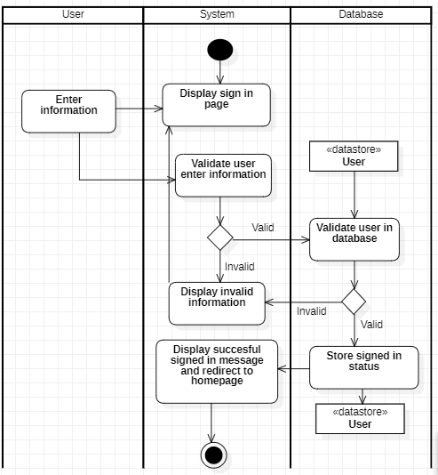

### Sign up

* **Sign up use-case specification**

|  |  |
| --- | --- |
| Use-case name | Sign up. |
| Primary actor | User |
| Description | User creates an account for all system services. |
| Trigger | User clicks on the button “Sign Up” or “Create an account”. |
| Pre-condition | User’s devices must be connected to the Internet. |
| Post-condition | User gets a notification about signing up successfully.  User’s account is created and can be used to sign in next time. |
| Basic flow | 1. User clicks on sign in /create an account button.  2. System displays sign up page.  3. User enters information such as email, password, name, ... and click confirm.  4. System validates customer entered information in the correct format.  5. System validates customer information unique to the database.  6. System stores customer information in the database.  7. System sends verification code via email.  8. System notifies user that account has been created, user can sign-in by using this account. |
| Alternative flow |  |
| Exception flow | 4a. System displays invalid information due to the wrong format.  Use-case continues at step 2.  5a. System displays invalid information due to an existing account with user entered information.  Use-case continues at step 2. |

* **Activity diagram:**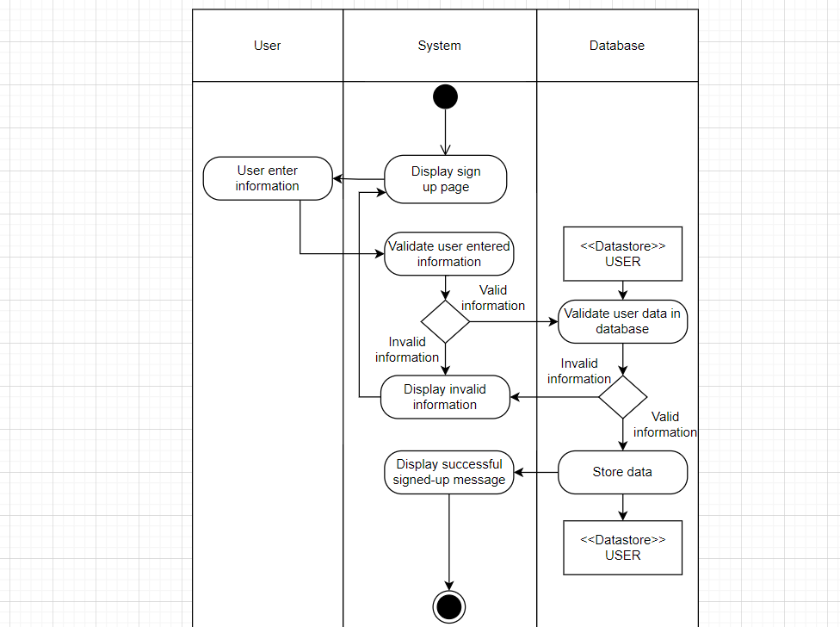

### Use-case manage cart

#### Insert Item to Cart

* **Insert item to Cart use-case specification:**

|  |  |
| --- | --- |
| **Use-case name** | **Insert menu** |
| Description | User can insert a new product to cart database. |
| Trigger | User clicks on button “ADD TO CART” at product page. |
| Precondition | User’s account existed.  User’s status is signed in. |
| Post-condition | Product successfully inserted into database.  Data at cart page is updated (with new item). |
| Basic flow | 1. User searches for information of the product.  2. User clicks on button “ADD TO CART”.  3. System sends request to database to check the inventory of the product.  4. System stores product information to Cart on the user’s session.  5. System displays success notification. |
| Alternative flow |  |
| Exception flow | 3a. System displays message “Product is out of stock!”.  Use case continues at step 1. |

* **Activity diagram:**

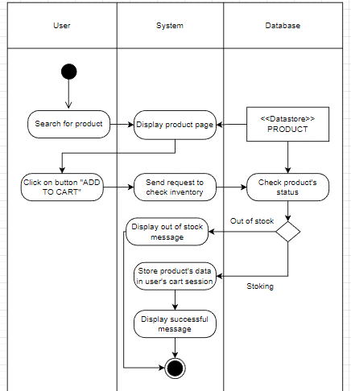

#### Delete Item from Cart

* **Delete item from Cart use-case specification:**

|  |  |
| --- | --- |
| Use-case name | Delete item for cart |
| Description | User can delete an existed product from cart |
| Trigger | Users click on button “Delete” at cart page |
| Precondition | User’s account existed  User’s status is signed in. |
| Post-condition | Data at cart page is updated (selected product had been deleted) |
| Basic flow | 1. System display cart page with data loaded from database (existed)  2. Users select delete function and item to be deleted  3. System processes delete request  4. System validates selected item exists in cart  5. System deletes product information in Cart page  6. System display data at Cart page with selected item deleted. |
| Alternative flow |  |
| Exception flow | 5a. System display error notification because no data existed  Use-case stop. |

* **Activity Diagram**

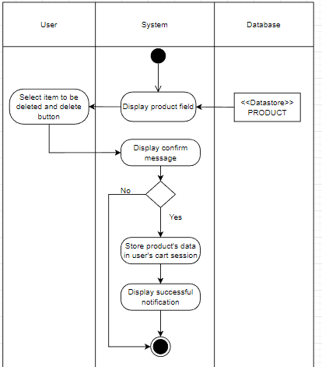

### Use-case manage account

* **Account management use-case specification:**

|  |  |
| --- | --- |
| Use-case name | Manage account |
| Primary actor | User |
| Description | Users can manage accounts, change passwords, and update information: name, email, address, phone number, and bank account... |
| Trigger | Users click to profile, change passwords, and update information. |
| Pre-Condition | User accounts existed.  The user's device must connect to the internet.  The user successfully signed in system. |
| Post-Condition | The system displays the user account information.  The system records the activities, changes new details on the account, and announces success or fail. |
| Basic flow | * The user clicks on the account icon to open the profile. * The system queries the user’s information based on the signed-in status. * The system displays on the page the user's private information. * Users change passwords or user information. * The system validates user’s information in the correct format. * The system stores new data in the database. * The system displays a successful message. |
| Alternative flow | N/A |
| Exception flow | 5a. System displays invalid information due to the wrong format.  Use case continues at step 3  6a. An error occurred while storing data.  Use case continues at step 3 |

* **Activity diagram**

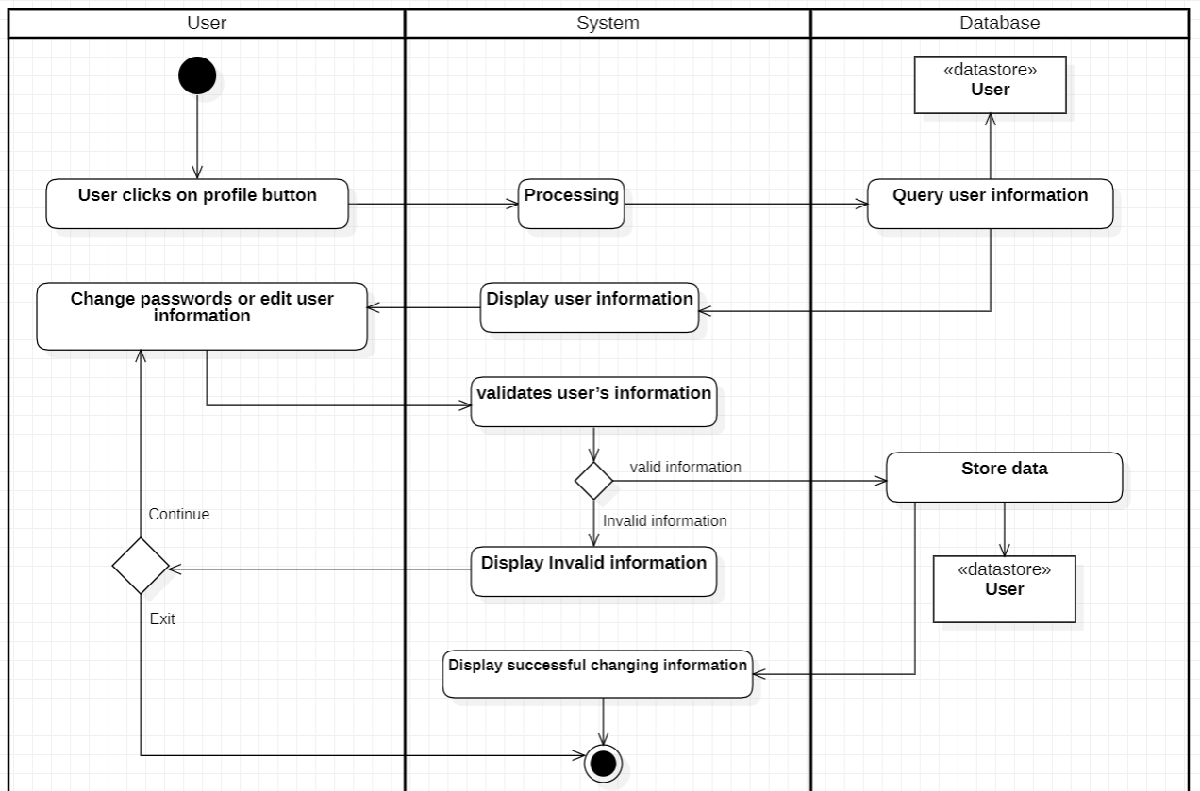

### Use-case purchase

* **Purchase use-case specification**

|  |  |
| --- | --- |
| Use-case name | Purchase |
| Primary actor | User |
| Description | Users can make purchases on the system. Perform operations such as: adding products to the cart, applying vouchers, making payments, and choosing a delivery method... |
| Trigger | Users want to buy products on the system. |
| Pre-condition | User accounts existed.  The user's device must connect to the internet.  The user successfully signed in system. |
| Post-condition | Display transaction results (success, failure).  Transaction information is stored in the database by the system. |
| Basic flow | 1. The user performs a product search with two entry points: using the search bar or clicking on the system's category.  2. The system processes information, the query based on the keyword, and the category displays the corresponding item list.  3. The user clicks an item (name, image...).  4. The system queries detailed information related to the product the user has selected: brand, screen size, storage capacity, processor, and warranty period...  5. The user adds an item to the cart.  6. The system saves the product to the cart.  7. The user selects items from the cart and confirms the purchase of the product (by clicking the “Buy Now” button).  8. The system checks inventory and approves orders, the system redirects users to the payment page: Product type, quantity, delivery address information, and total invoice...  9. User uses the voucher, selects the shipping method, and chooses the payment method (Payment on receipt, bank account...).  10. The user chooses the default delivery information or edits it.  11. User clicks "Payment".  12. The system displays a message asking if the user is "Are you sure you want to buy this item?". If you agree, the transaction continues.  13. Invoice recording system, payment processing, and information storage in the database.  14. The system displays a successful transaction or failed notification to the user. If the transaction is successful send the invoice to the email and redirect the user to the homepage. |
| Alternative flow | N/A |
| Exception flow | * The system shows the error, "no shipping method available for product". * Error: Quantity or volume of the product exceeds the allowable. * Payment error: Insufficient online account balance. * Error: Voucher/Discount Code cannot be used.   "Sorry! This voucher has expired.”  "Expired",  "Used",  “The selected product is not eligible for the Voucher…”,  “Choose the right payment method to use the free shipping code. The selected payment method is not eligible to use this voucher.” |

* **Activity diagram**

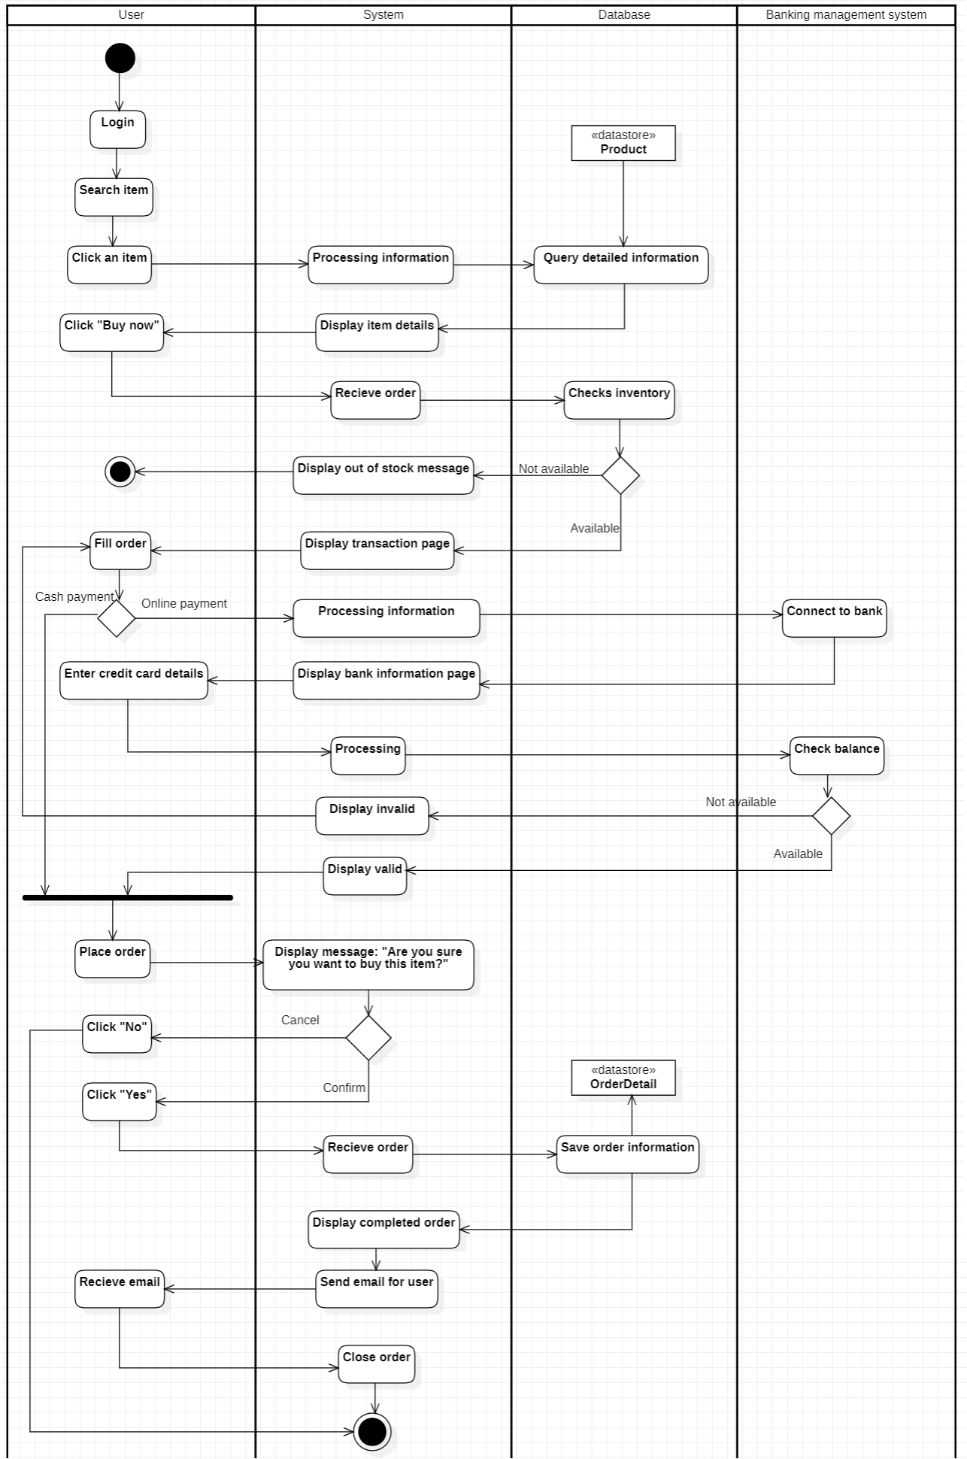

### Use-case manage transaction history

* **Manage transaction history specification**

|  |  |
| --- | --- |
| Use-case name | Manage transaction history. |
| Primary actor | Customer. |
| Description | Users can review the transaction history on the system. |
| Trigger | Customers click to the “Profile” button and select the transaction history. |
| Pre-condition | User accounts existed.  The user's device must connect to the internet.  The user successfully signed in system. |
| Post-condition | Users receive transaction history, and detailed product information: successful, canceled... |
| Basic flow | 1. User clicks "profile" and selects transaction history.  2. The system queries transactions by user ID, phone number, or citizen identification.  3. The system displays transaction history on the page with detailed information. |
| Alternative flow | N/A |
| Exception flow | N/A |

* **Activity diagram**

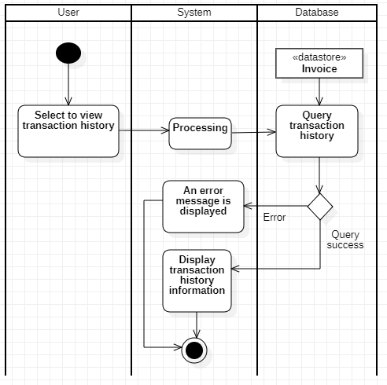

### Use-case order tracking

* **Order tracking use-case specification:**

|  |  |
| --- | --- |
| Use-case name | Order tracking |
| Primary actor | User |
| Description | As users, they want to track their order |
| Trigger | Users want to track orders |
| Pre-Condition | User accounts existed.  The user's device must connect to the internet.  The user successfully signed into the system. |
| Post-Condition | The system shows the status of user’s order. |
| Basic flow | 1. User clicks on order tracking.  2. System processing.  3. Database will check order information.  4. System confirmed with status: Confirmed, delivering, delivered.  5. The system will display the user's order status. |
| Alternative flow | N/A |
| Exception flow | N/A |

* **Activity diagram:**

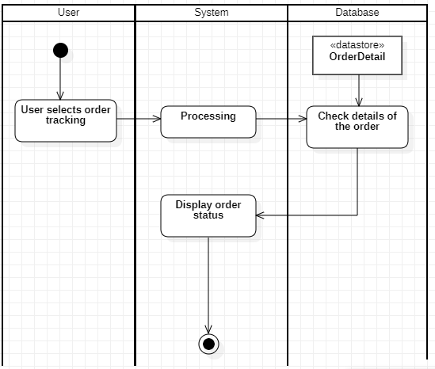

### Return and refund policy

* **Return and refund policy use-case specification:**

|  |  |
| --- | --- |
| Use-case name | Return and refund policy |
| Primary actor | User. |
| Description | As users, they want to warrant their products. |
| Trigger | Users want to return and refund the purchased products. |
| Pre-Condition | User accounts existed.  The user's device must connect to the internet.  The user successfully signed into the system.  The user has purchased at the shop. |
| Post-Condition | The system will notify the user know the admin agree to Policy change and refund or not. |
| Basic flow | 1. System will display purchased product  2. Users click on Policy change and refund.  3. System will display information form  4. Users will enter information and details product pictures  5. The system will save the data to the database.  6. Admin will check the information on the database.  7. Admin will decide about orders.  8. Send notifications to the user. |
| Alternative flow | 7a. Admin agrees to return policy.  7b. Admin disagrees to return policy and give reasons. |
| Exception flow | N/A |

* **Activity diagram:**

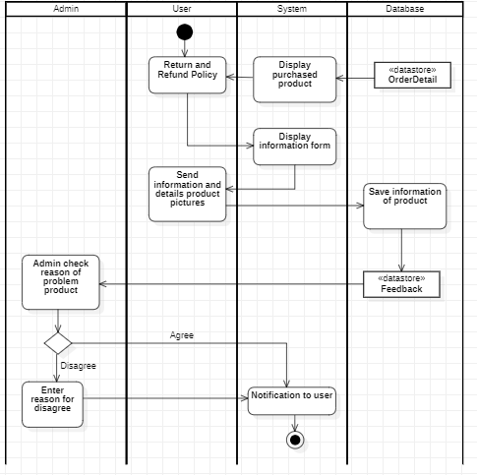

### Notification

* **Notification use-case specification:**

|  |  |
| --- | --- |
| Use-case name | Notification |
| Primary actor | User |
| Description | As users, they want to view shop notifications |
| Trigger | The user wants to view shop notifications about order status, Vouchers, System maintenance. |
| Pre-Condition | User accounts existed.  The user's device must connect to the internet.  The user successfully signed into the system. |
| Post-Condition | The system will show all notifications |
| Basic flow | 1. User clicks on Notification Button.  2. Processing.  3. The database will query for information about order status, Vouchers, System maintenance.  4. The system will display all notifications. |
| Alternative flow | N/A |
| Exception flow | N/A |

* **Activity diagram:**

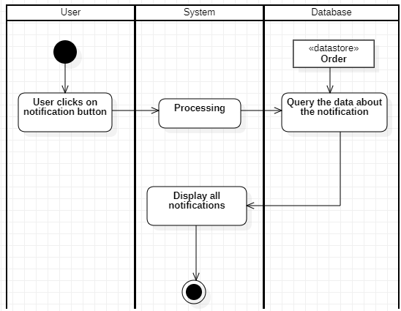

### User management

#### Insert new user

|  |  |
| --- | --- |
| Use-case name | Insert user |
| Primary actor | Admin |
| Description | Admin can insert new user to login into the system |
| Trigger | Admin clicks on button Create |
| Pre-condition | Admin’s account existed  Admin logins into system successfully using admin’s account |
| Post-condition | User’s succesfully added into system |
| Basic flow | 1.Admin chooses “User management” on side bar  2.System displays User management page  3.Admin clicks on button “Create new user”  4.System displays Create user page  5.Admin fills in information form and clicks “Create”  6.Client checks submit validation  7. System inserts new user to User database  8.System display success message and reload User management page |
| Alternative flow |  |
| Exception flow | 5a. Admin clicks  6a. System displays error message due to wrong input format  Use case continues at step 3 |

* **Activity diagram:**

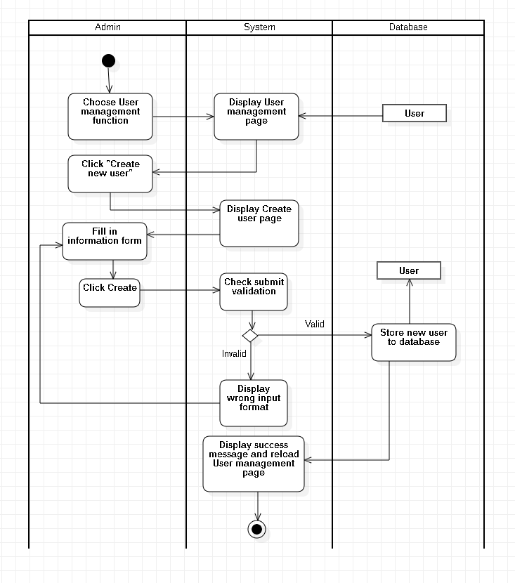

#### Delete user

|  |  |
| --- | --- |
| Use-case name | Delete user |
| Primary actor | Admin |
| Description | Admin can delete user information |
| Trigger | Admin clicks on button delete |
| Pre-condition | Admin’s account existed  Admin logins into system successfully using admin’s account |
| Post-condition | User’s successful deleted in system |
| Basic flow | 1.Admin chooses “User management” on side bar  2.System displays User management page  3.Admin clicks “Delete” button on user whom he wants to delete  4.System displays confirm delete page  5.Admin clicks on “Delete” button to perform delete action  6.System finds and deletes user’s data in database  7.System Display success message and reload User management page |
| Alternative flow |  |
| Exception flow | 6a. System displays error message because user doesn’t exist  Use case continues at step 3 |

* **Activity diagram:**

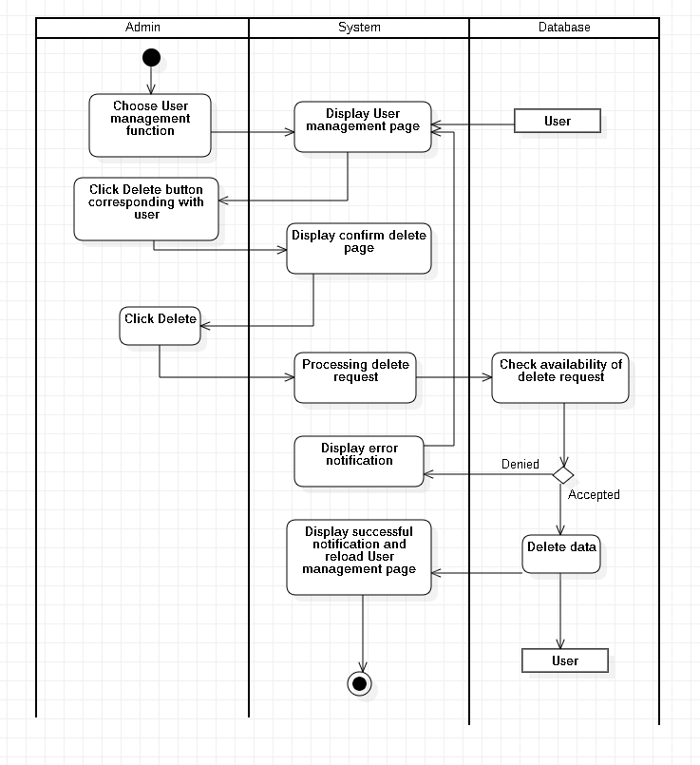

#### Update user

|  |  |
| --- | --- |
| Use-case name | Update user |
| Primary actor | Admin |
| Description | Admin can update information of users |
| Trigger | Admin clicks on “Update” button |
| Pre-condition | Admin’s account existed  Admin logins into system successfully using admin’s account |
| Post-condition | User’s information is updated successfully |
| Basic flow | 1.Admin chooses “User management” on side bar  2.System display User management page  3.Admin clicks “Update” on user whom he wants to update information  4.System displays user’s information page  5.Admin edits information form of the user  6.Admin clicks on “Update” button  7.Client checks input format  8.System saves updated information in database  9.System displays success message |
| Alternative flow |  |
| Exception flow | 6a. System displays wrong input format in client session  Use case continues at step 5  8a. System errors due to server or database crash  Use case continues at step 5 |

* **Activity diagram:**

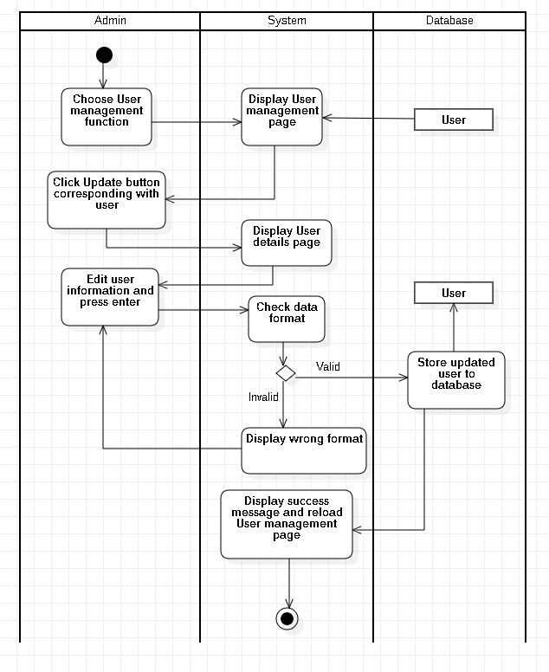

### Order management

#### Search for order

|  |  |
| --- | --- |
| Use-case name | Search for order |
| Primary actor | Admin |
| Description | Admin can use search function to seek for order |
| Trigger | Admin clicks on the lens icon or presses enter |
| Pre-condition | Admin’s account existed  Admin logins into system successfully using admin’s account |
| Post-condition | The specific order is displayed |
| Basic flow | 1.Admin chooses “Order management” on side bar  2.System display Order management page  3.Admin inputs order information which he wants to check in search field, then press enter  4.System queries database to find Order’s information match with Admin’s input  5.System displays order’s information |
| Alternative flow | 4a. If no order matchs with the input, system displays empty result.  Use case stop |
| Exception flow |  |

* **Activity diagram:**

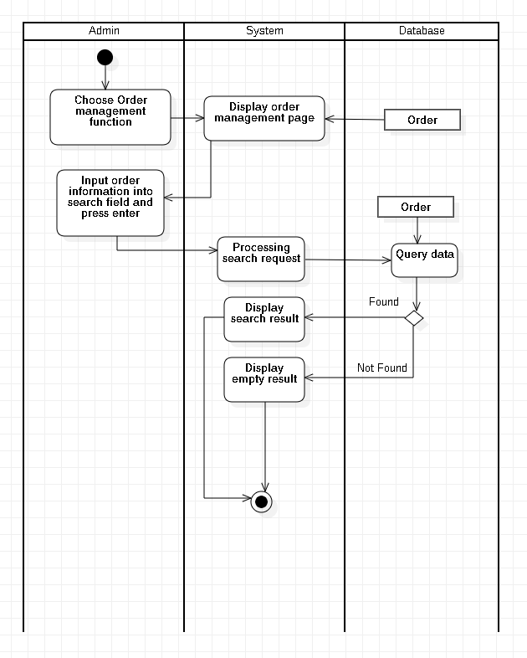

#### Delete order

|  |  |
| --- | --- |
| Use-case name | Delete order |
| Primary actor | Admin |
| Description | Admin can delete order’s information |
| Trigger | Admin clicks on “Delete” button |
| Pre-condition | Admin’s account existed  Admin logins into system successfully using admin’s account |
| Post-condition | The specific order is deleted |
| Basic flow | 1.Admin chooses “Order management” on side bar  2.System displays Order management page  3.Admin clicks “Delete” on the order which he wants to delete  4.System displays confirm delete page  5.Admin clicks on “Delete” button  6.System finds and deletes order’s data in database  7.System displays successful dialog |
| Alternative flow |  |
| Exception flow | 6a. System shows error dialog if it can not find order’s information  Use case continues at step 2 |

* **Activity diagram:**

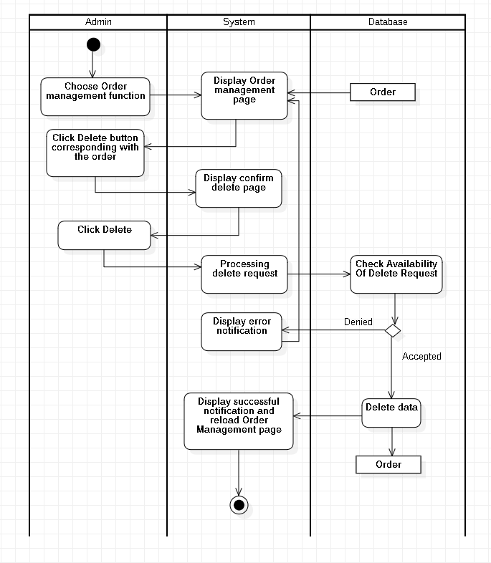

### Item management

#### Insert item

|  |  |
| --- | --- |
| Use-case name | Insert item |
| Primary actor | Admin |
| Description | Admin can insert new product into ecommerce shop |
| Trigger | Admin clicks on button “Create” |
| Pre-condition | Admin’s account existed  Admin logins into system successfully using admin’s account |
| Post-condition | Item successfully added into ecommerce shop |
| Basic flow | 1.Admin chooses “Product management”  2.System displays a list of products  3.Admin clicks on “Create new item” button  4.System displays Create product page  5.Admin fills in new product’s form and click “Create”  6.Client checks input validation  7.System stores new product into Product database  8.System displays successful message |
| Alternative flow |  |
| Exception flow | 6a. System displays wrong input format  Use case continues at step 5  7a. System displays error message due to server or database crash.  Use case continues at step 4 |

* **Activity diagram:**

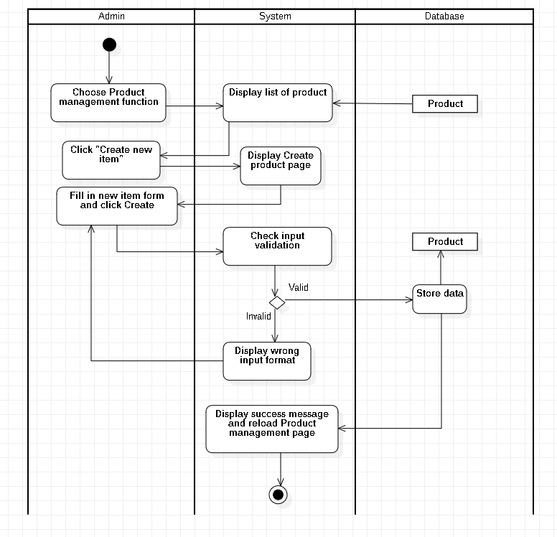

#### Update item

|  |  |
| --- | --- |
| Use-case name | Update item |
| Primary actor | Admin |
| Description | Admin can update item’s information |
| Trigger | Admin click on button “Update” |
| Pre-condition | Admin’s account existed  Admin logins into system successfully using admin’s account |
| Post-condition | Item’s updated successfully |
| Basic flow | 1.Admin chooses “Product management”  2.System displays a list of products  3.Admin clicks on “Update” button corresponding with item that he wants to update  4.System displays Product’s details page  5.Admin edits information form and click “Update” button  6. Client checks input validation  7.System updates product into Product database  8.System displays successful message |
| Alternative flow |  |
| Exception flow | 6a. System displays wrong input format  Use case continues at step 5 |

* **Activity diagram:**

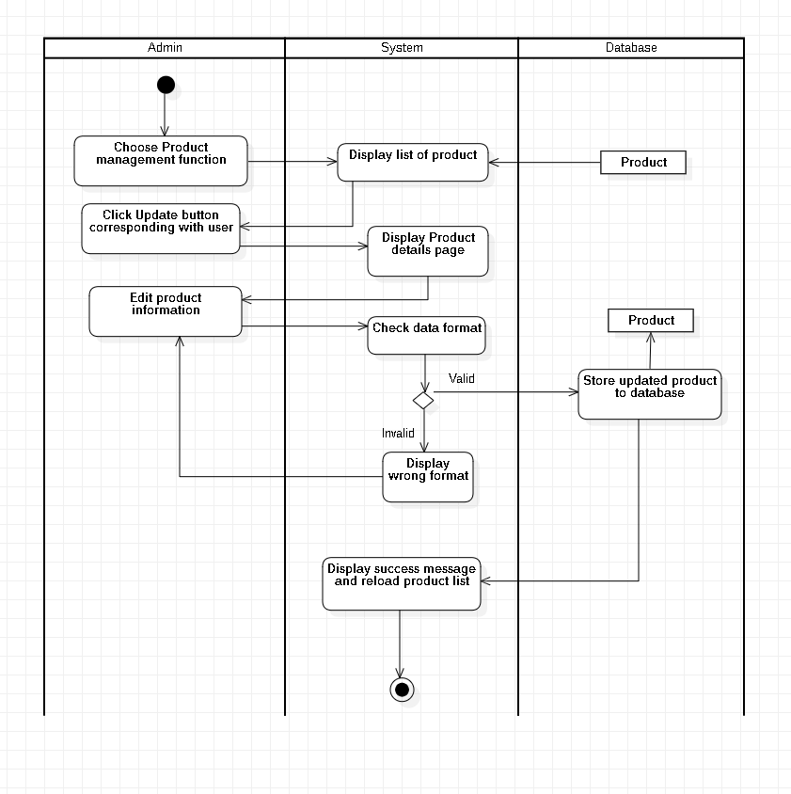

#### Delete item

|  |  |
| --- | --- |
| Use-case name | Delete item |
| Primary actor | Admin |
| Description | Admin can delete item that he doesn’t want to sell or display anymore |
| Trigger | Admin clicks on “Delete” button |
| Pre-condition | Admin’s account existed  Admin logins into system successfully using admin’s account |
| Post-condition | Item is deleted successfully |
| Basic flow | 1.Admin chooses “Product management”  2.System displays a list of products  3.Admin clicks on “Delete” button corresponding with item that he wants to delete  4.System displays confirm delete page  5.Admin clicks “Delete” button  6.System finds and deletes product in Product database  7.System displays successful message |
| Alternative flow |  |
| Exception flow | 7a. System shows error because user doesn’t exist  Use case continues at step 2 |

* **Activity diagram:**

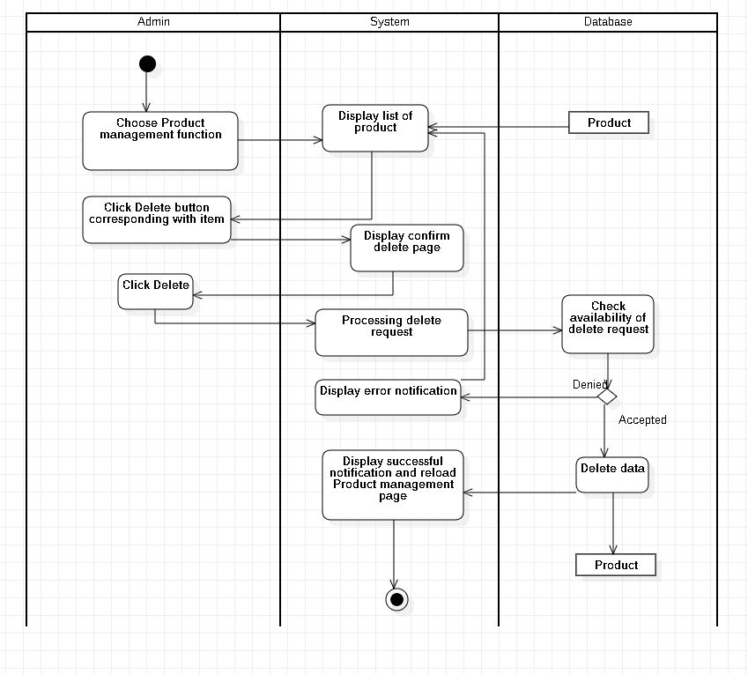

#### Search for item

|  |  |
| --- | --- |
| Use-case name | Search for item |
| Primary actor | Admin |
| Description | Admin can search for item |
| Trigger | Admin inputs item’s information in search field and press enter |
| Pre-condition | Admin’s account existed  Admin logins into system successfully using admin’s account |
| Post-condition | The specific item is displayed |
| Basic flow | 1.Admin chooses “Product management”  2.System displays a list of products  3.Admin inputs item information in search field and press enter  4.System queries database to find item’s information match with information in search field  5.System displays item’s information |
| Alternative flow |  |
| Exception flow | 4a. If no item matchs with the input, system displays empty result.  Use case continues at step 3 |

* **Activity diagram:**

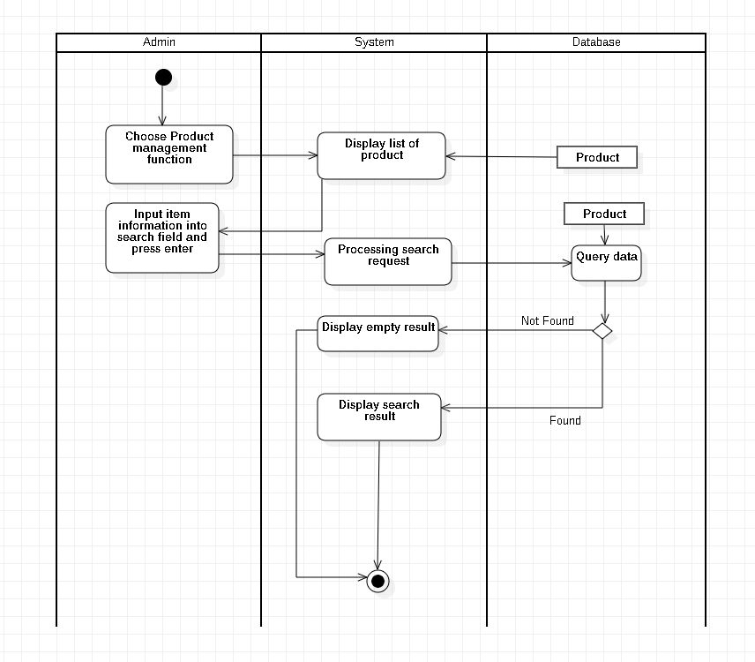

### Sales partner management

#### Insert new Sales partner

|  |  |
| --- | --- |
| Use-case name | Insert sales partner |
| Primary actor | Admin |
| Description | Admin can insert partner’s information to database |
| Trigger | Admin clicks on button “Insert” at partner management page |
| Pre-condition | Admin’s account existed  Admin’s status is signed-in |
| Post-condition | Membership information successful inserted to database  Data at management page is updated (with new membership) |
| Basic flow | 1. System displays partner management page with data loaded from database (existed partners)  2. Admin enters partner information  3. System validates partner information in correct format  4. System validates partner information with existing data in the database.  5. System stores partner information in database  6. System updates data at sales partner management page with inserted data (new data). |
| Alternative flow |  |
| Exception flow | 3a. System displays invalid information due to the wrong format.  Use-case continues at step 2.  4b. System display invalid information because data had been existed in the database.  Use-case continues at step 2. |

* **Activity diagram:**

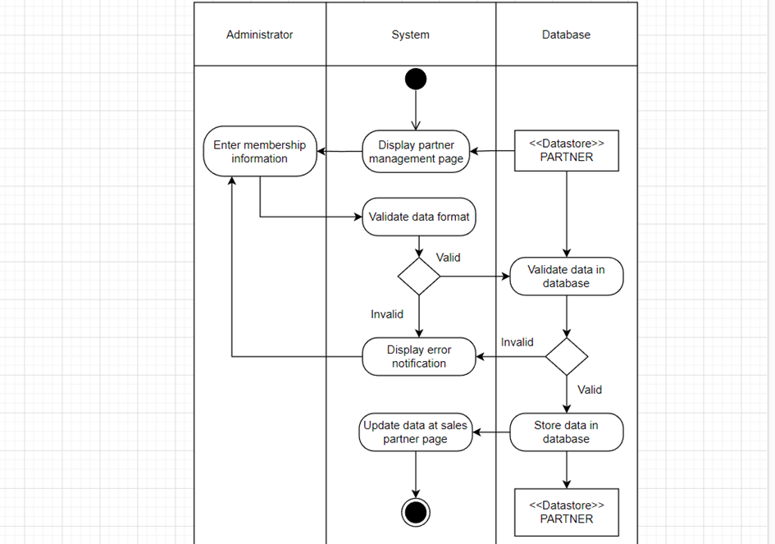

#### Update Sales partner

|  |  |
| --- | --- |
| Use-case name | Update Sales partner |
| Primary actor | Admin |
| Description | Admin can update Sales partner information |
| Trigger | Admin click on button “Update” |
| Pre-condition | Admin’s account existed  Admin logins into system successfully using admin’s account |
| Post-condition | Sales partner is update successfully |
| Basic flow | 1.Admin chooses “Sales partner manager”  2.System displays a list of sales partners  3.Admin clicks on “Update” button corresponding with sales partner he wants to update  4.System displays sales partner is information page  5.Admin edits information form and click “Update” button  6.Client checks input format  7.System updates information in database  8.System displays success message |
| Alternative flow | 6a. System displays wrong input format  Use case continues at step 5 |
| Exception flow |  |

* **Activity diagram:**

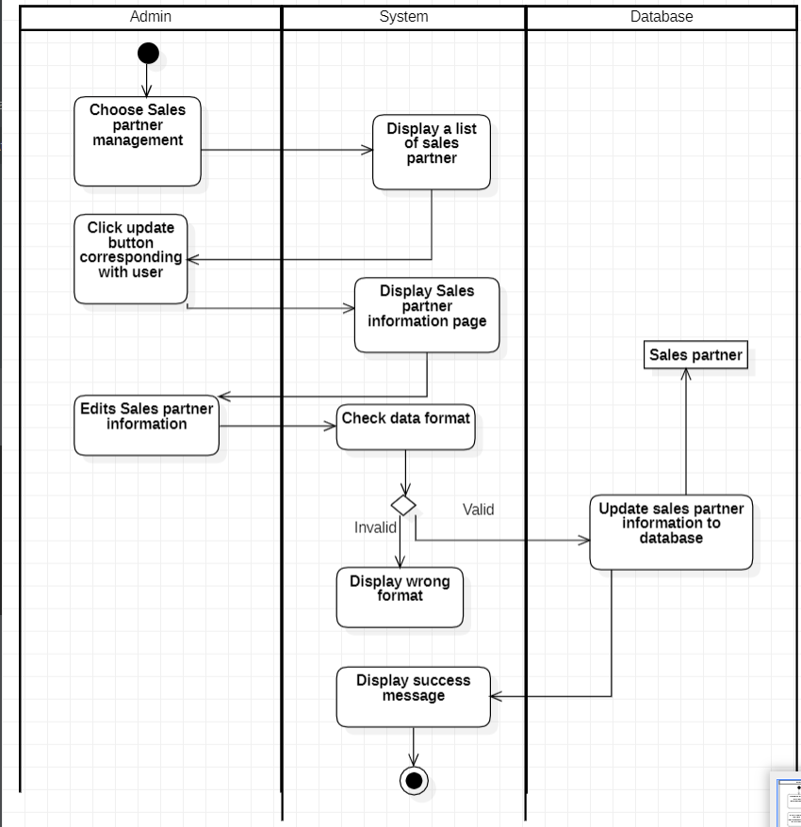

#### Delete Sales partner

|  |  |
| --- | --- |
| Use-case name | Delete sales partner |
| Primary actor | Admin |
| Description | Admin can delete an existed partner’s information from database |
| Trigger | Admin clicks on button “Delete” at manage partner page |
| Pre-condition | Admin’s account existed  Admin’s status is signed in.  Partner information must be existed in database before deleting. |
| Post-condition | Data at management page is updated (selected partner had been deleted) |
| Basic flow | 1. System displays partner management page with data loaded from database (existed membership)  2. Admin selects partner to be deleted and delete button.  3. System displays confirm message  4. System deletes partner information in the database  5. System updates data at partner management page with selected item deleted. |
| Alternative flow |  |
| Exception flow | 3a. Admin chooses no  Use-case stop. |

* **Activity diagram:**

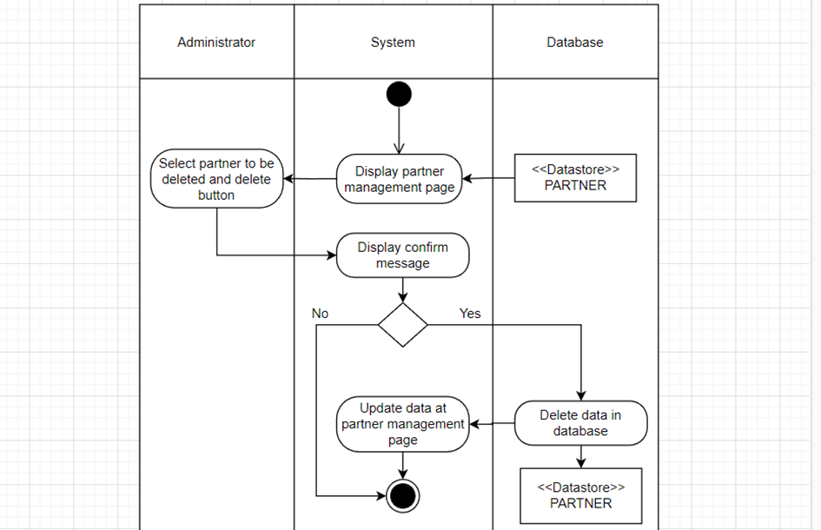

#### Search for Sales partner

|  |  |
| --- | --- |
| Use-case name | Search for Sales partner |
| Primary actor | Admin |
| Description | Admin can search for Sales partner |
| Trigger | Admin inputs sales partner is information in search field and press enter |
| Pre-condition | Admin’s account existed  Admin logins into system successfully using admin’s account |
| Post-condition | Sales partner information is display |
| Basic flow | 1. Admin chooses “Sales partner management”  2.System displays a list of sales partner  3.Admin inputs information in search field and press enter  4.System queries database to find sales partner is  5.System displays information of sales partner |
| Alternative flow |  |
| Exception flow | 4a. If no information matchs with the input, System display empty result |

* **Activity diagram:**

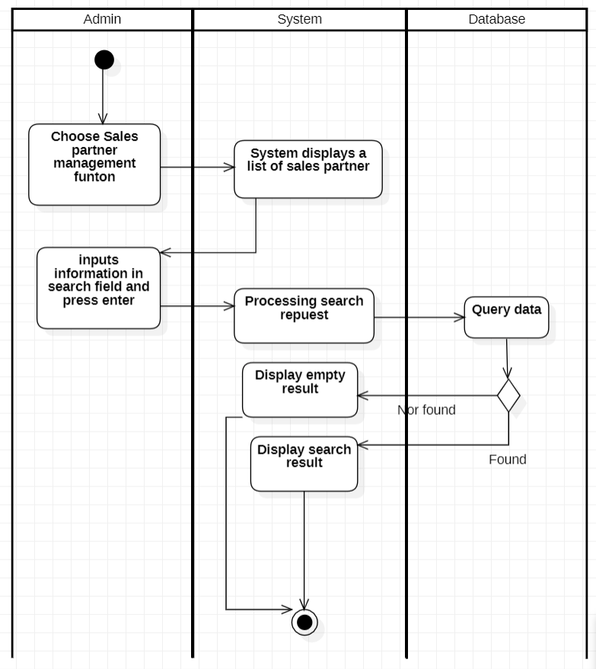

### Tracking transaction history

|  |  |
| --- | --- |
| Use-case name | Tracking transaction history |
| Primary actor | Admin |
| Description | Admin can track transaction history |
| Trigger | Admin click on button “order manager” |
| Pre-condition | Admin’s account existed  Admin logins into system successfully using admin’s account |
| Post-condition | System display transaction history |
| Basic flow | 1.Admin chooses “transaction history” function  2. The system queries transactions history from invoice  3. The system displays transaction history on the page. |
| Alternative flow |  |
| Exception flow |  |

* **Activity diagram:**

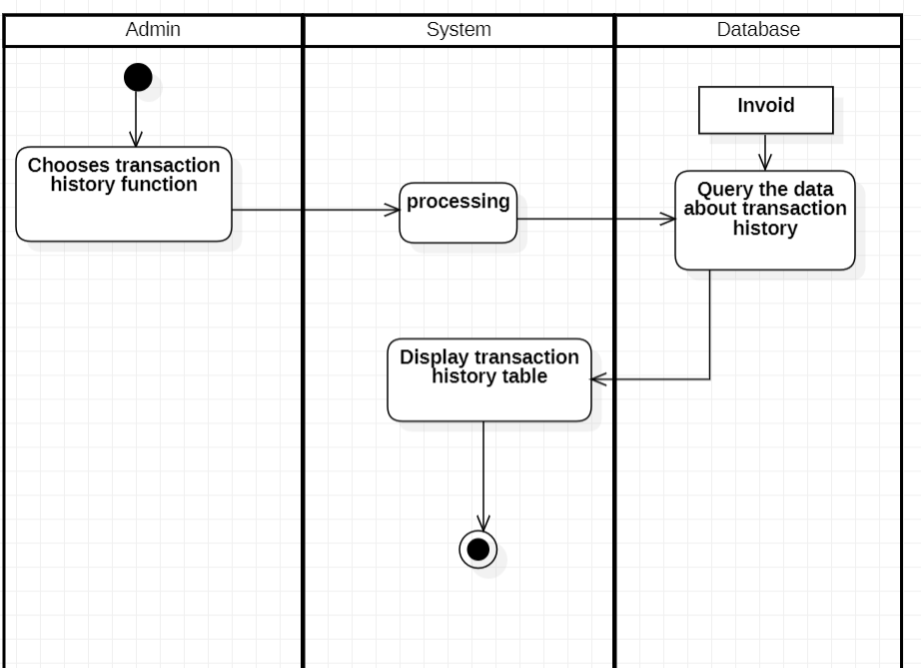

## Sequence diagram and Class diagram

### Sign in

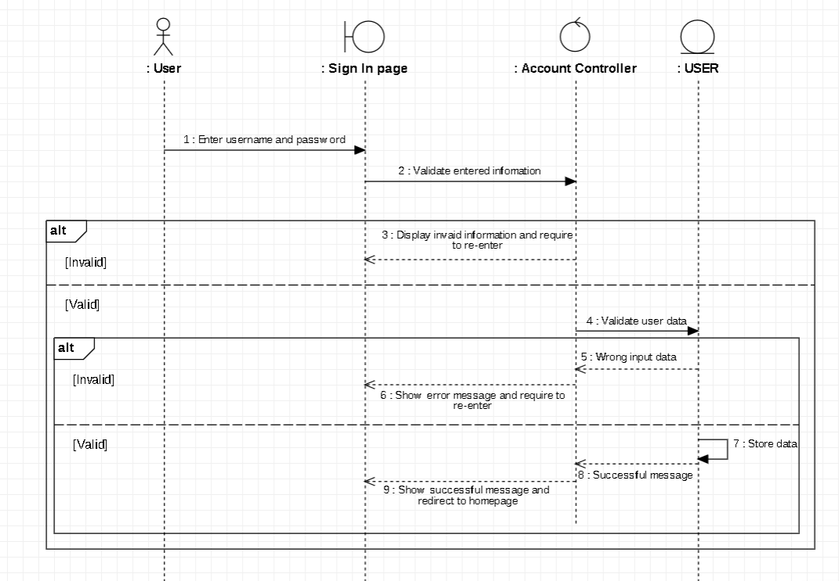

* **Class diagram**

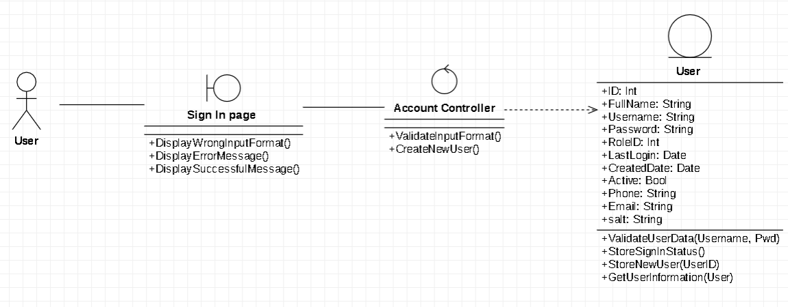

### Sign up

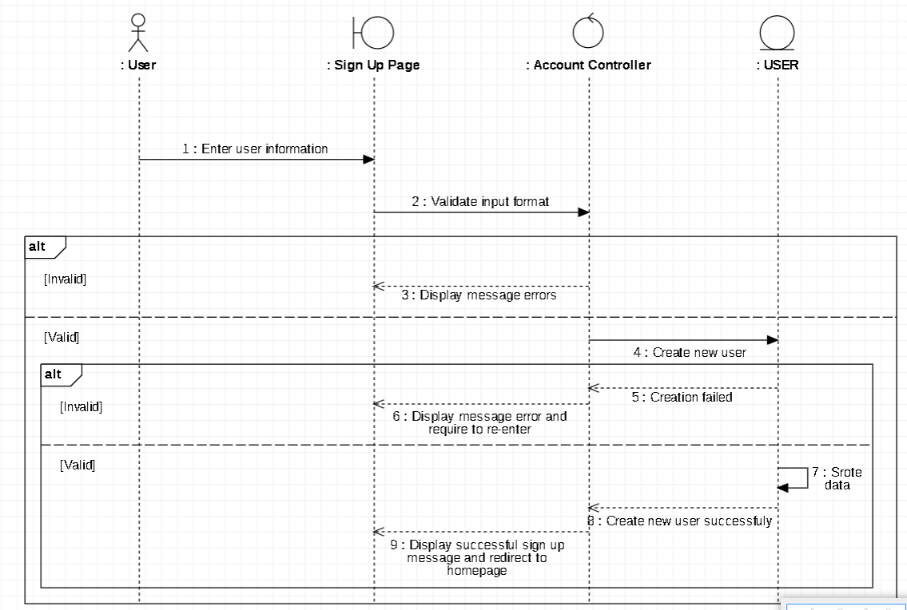

* **Class diagram**

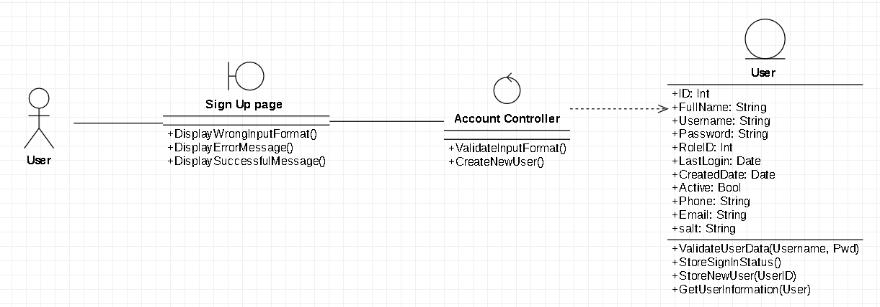

### Manage cart

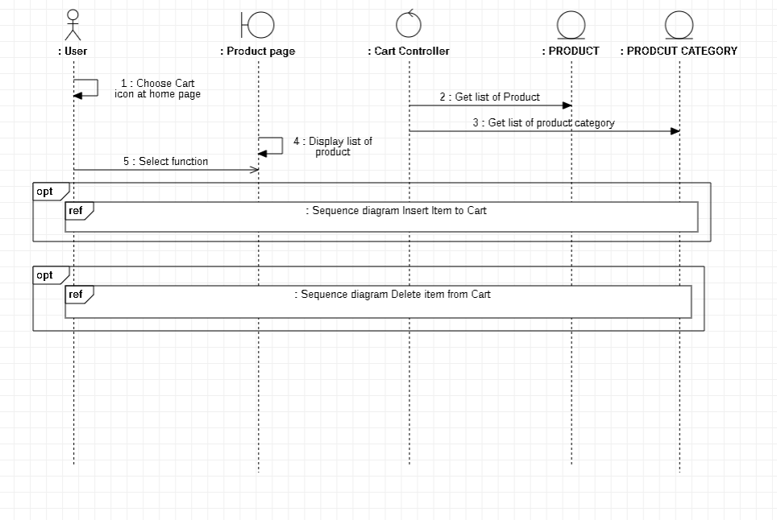

#### Insert item to cart

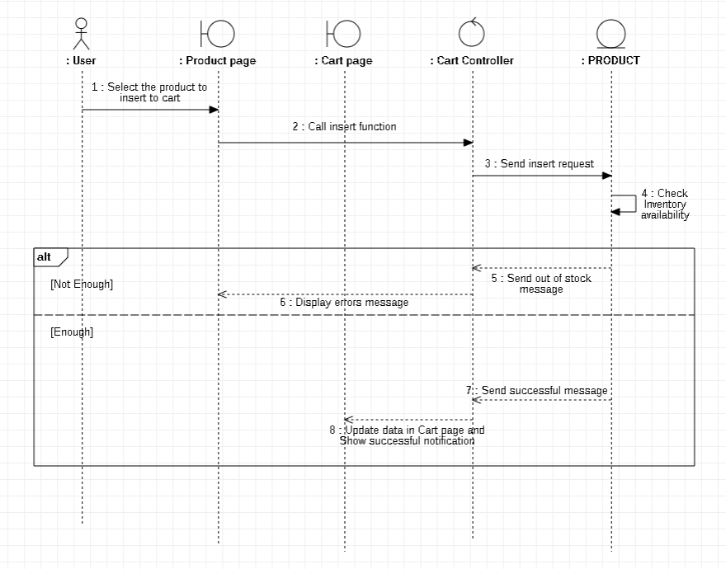

#### Delete item from cart

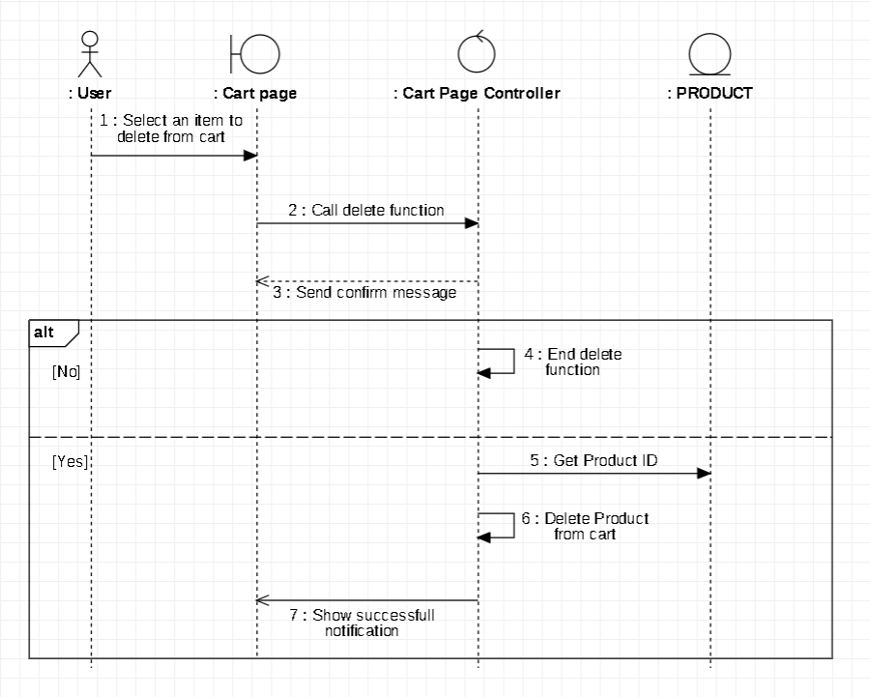

* ` **Class diagram**

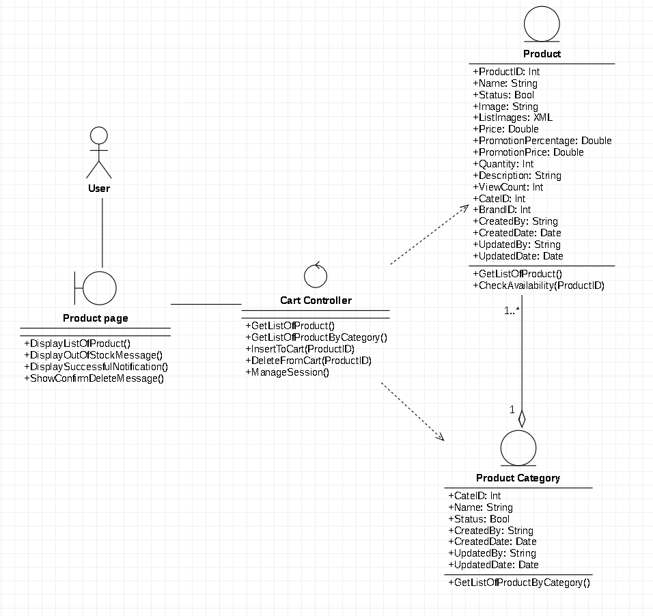

### Manage account

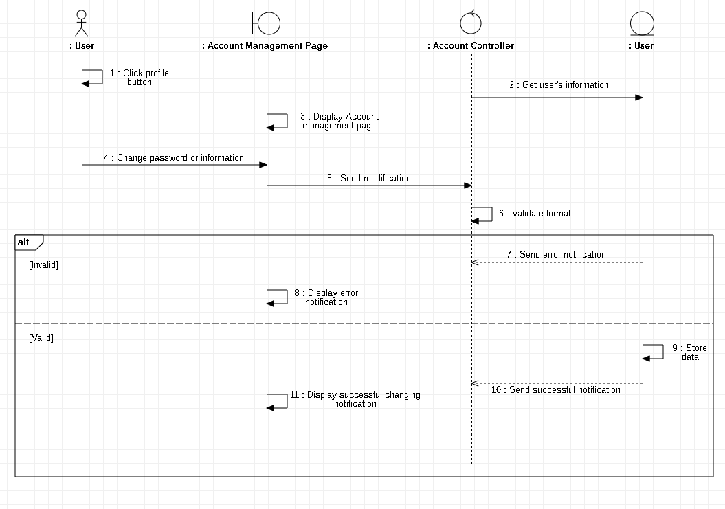

* **Class Diagram**

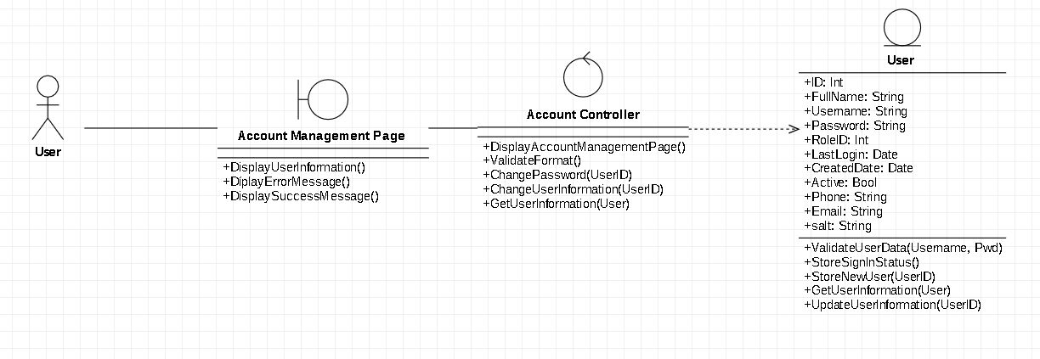

### Purchase

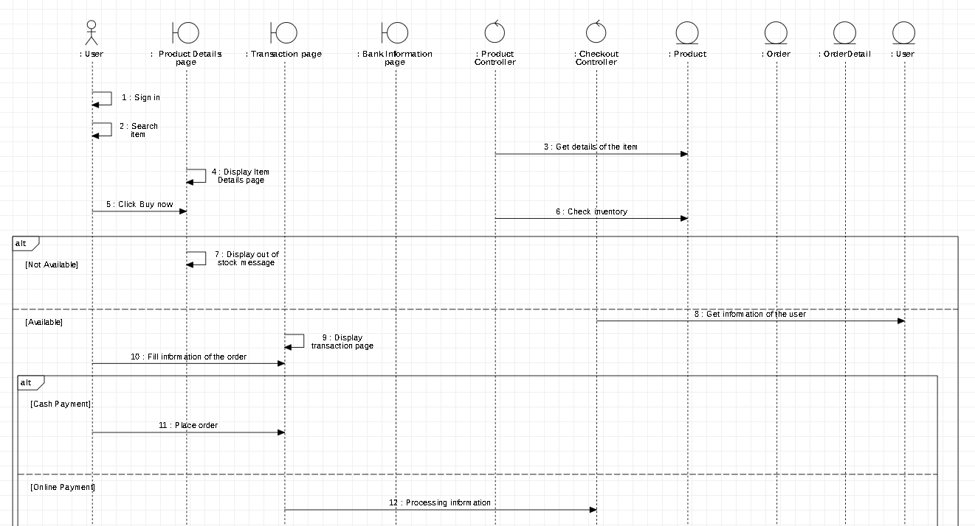

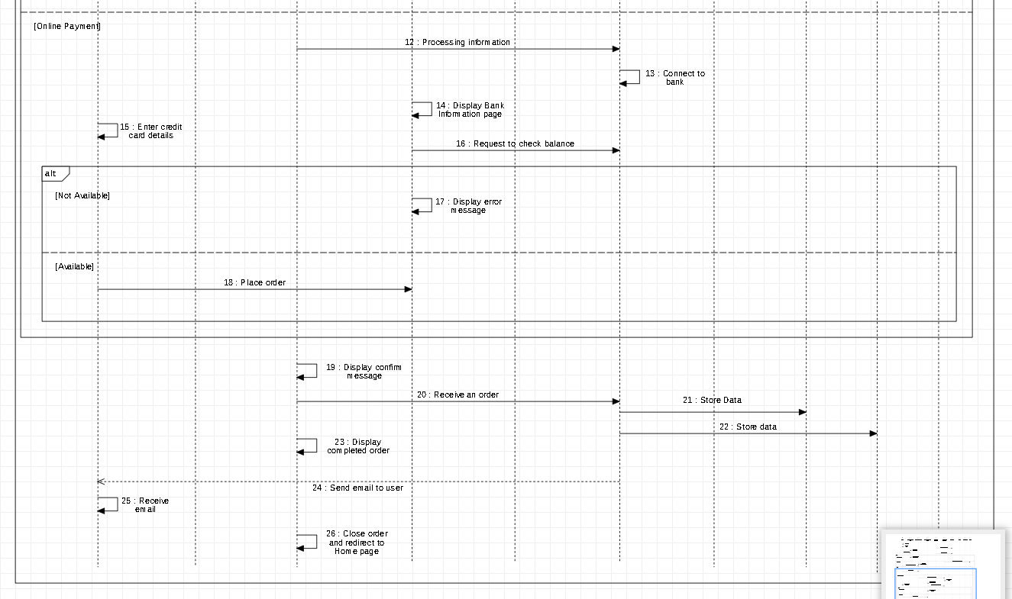

* **Class Diagram**

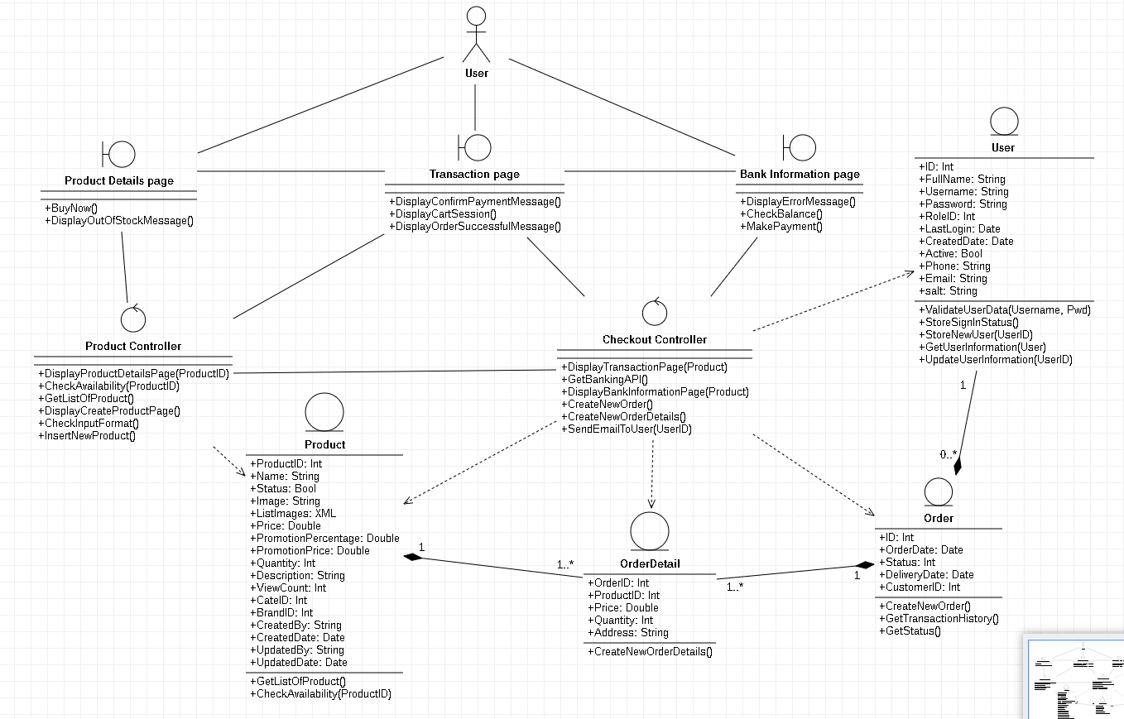

### Tracking transaction history

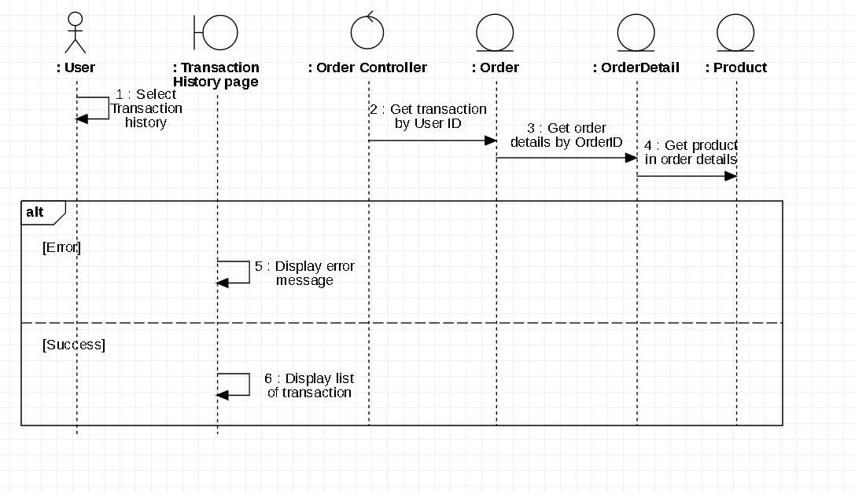

* **Class Diagram**

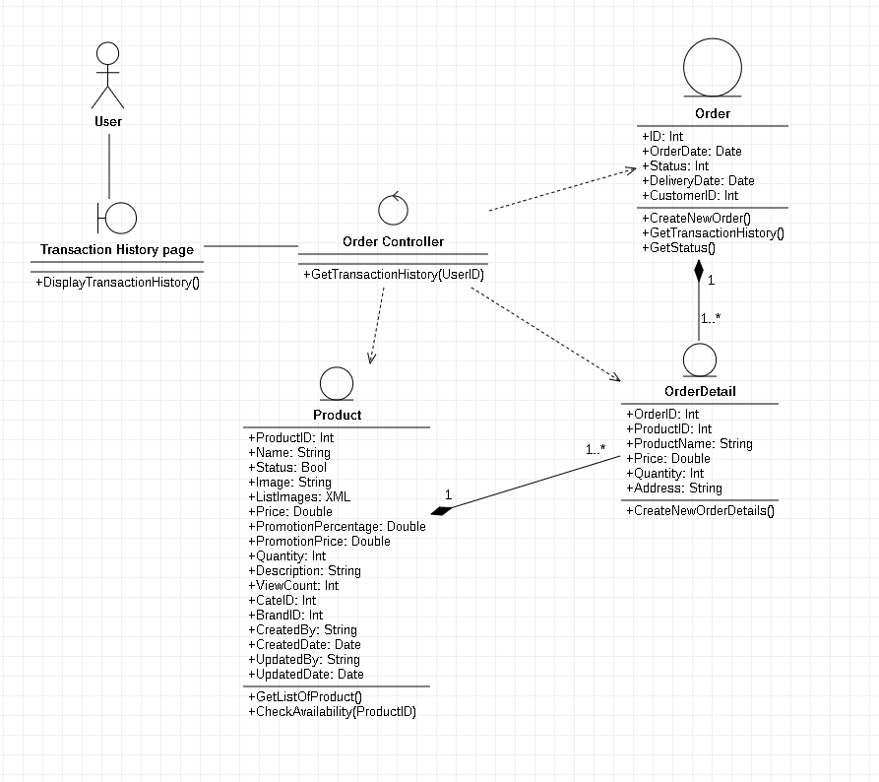

### Tracking order

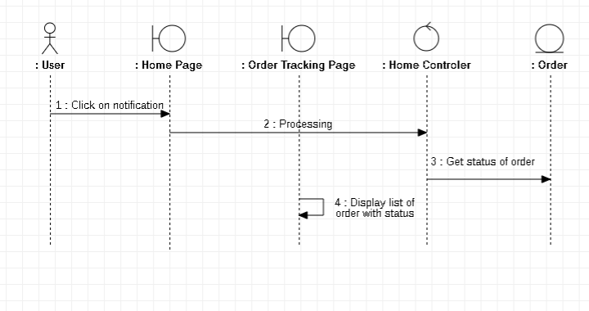

* **Class Diagram**

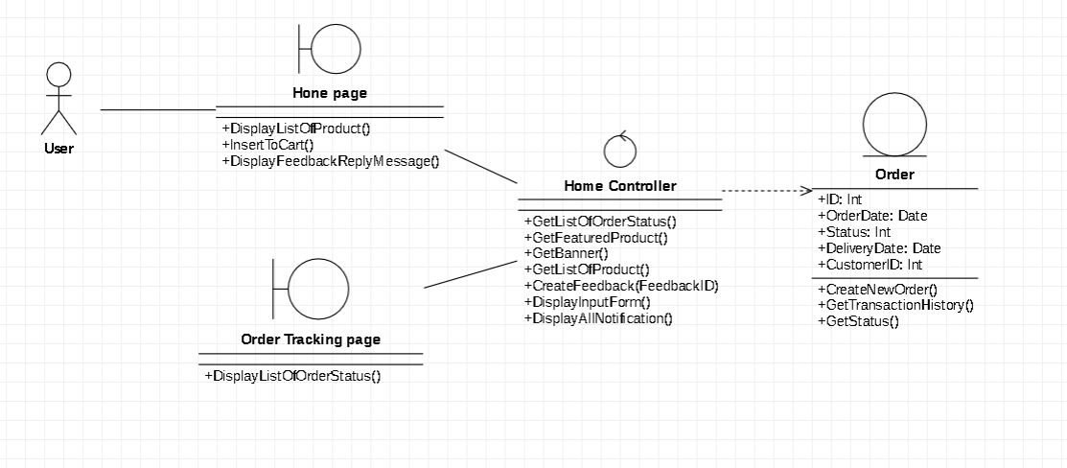

### Return and refund policy

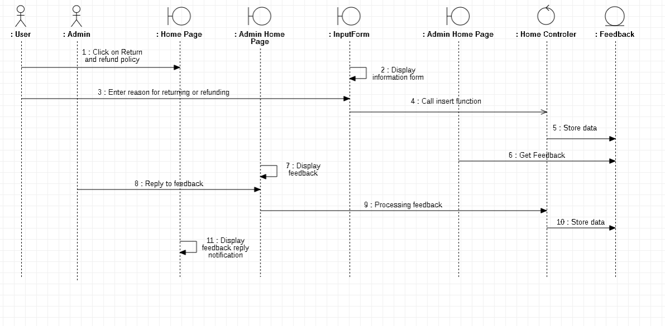

* **Class Diagram**

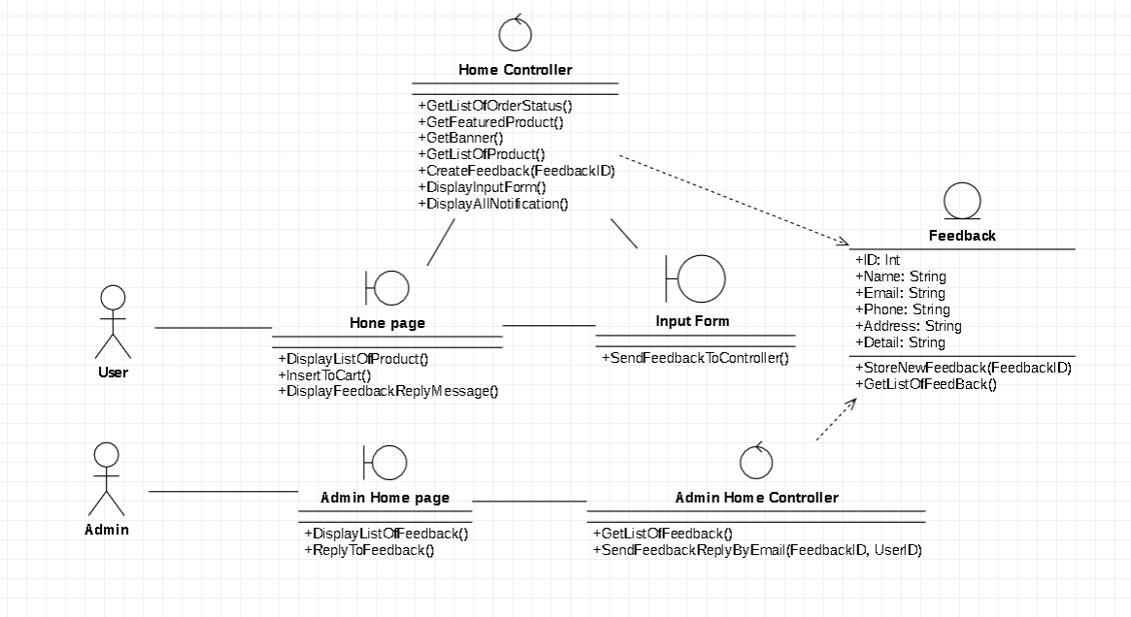

### Notification

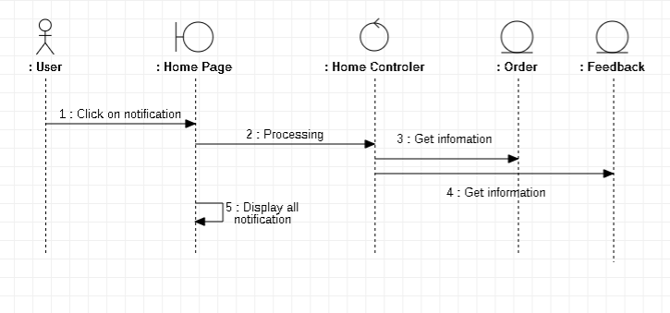

* **Class Diagram**

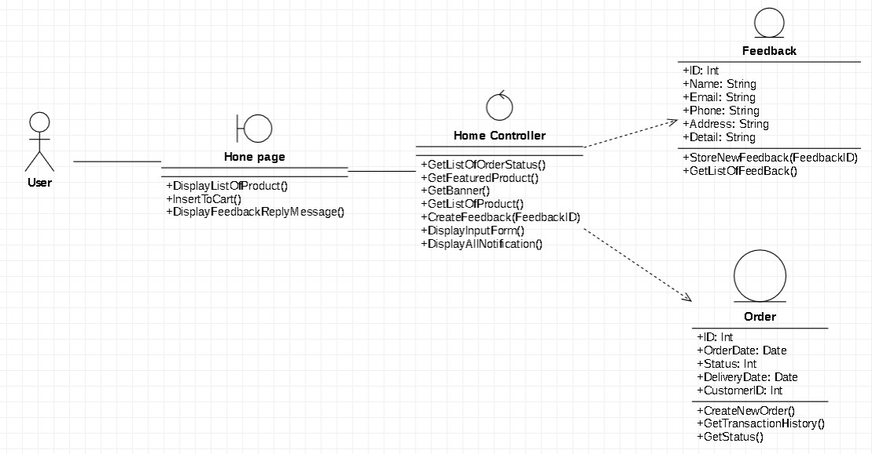

### User management

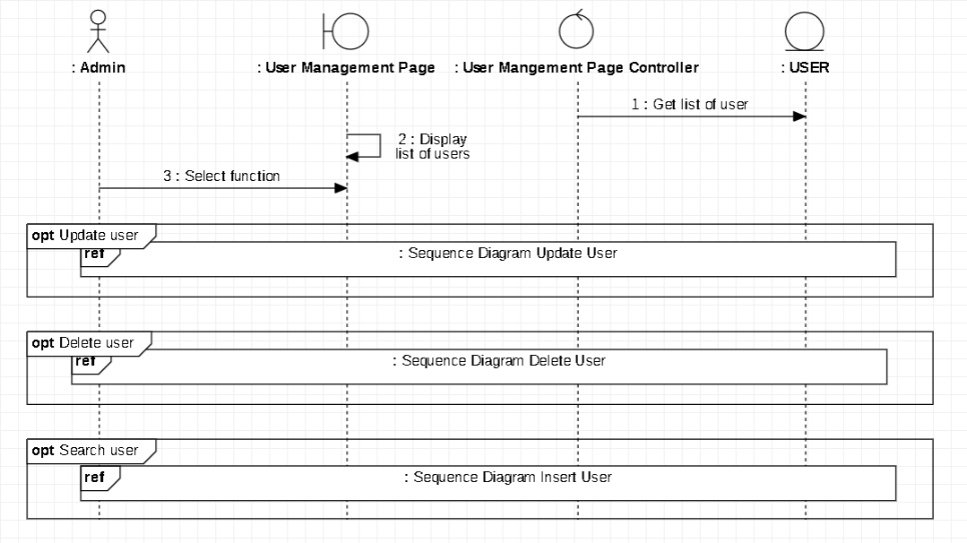

#### Insert new user

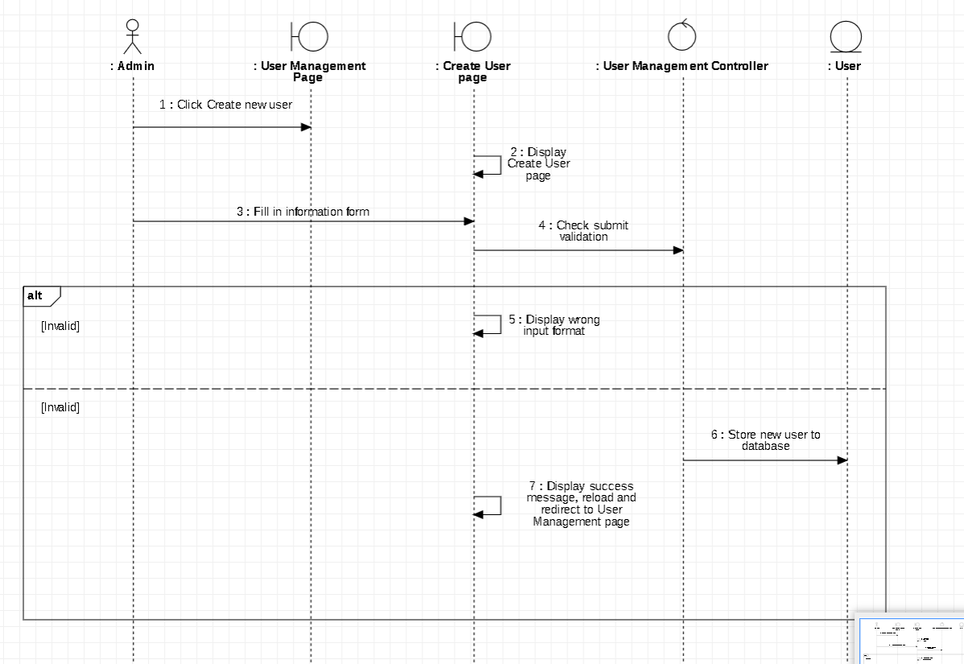

#### Delete user

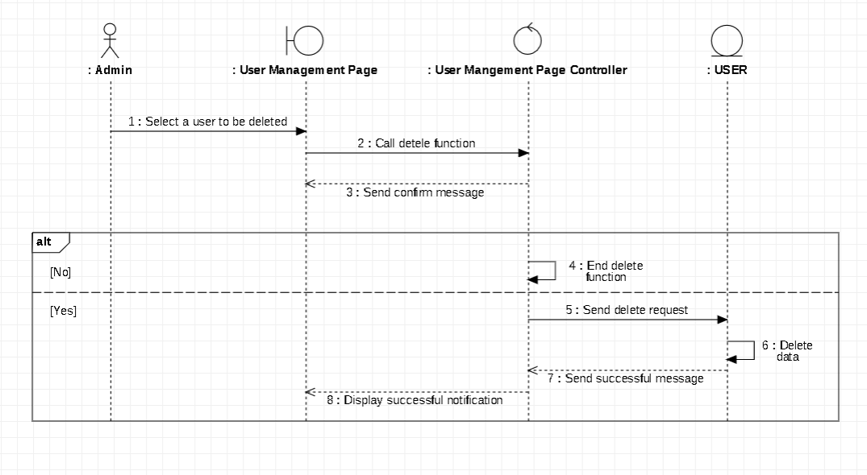

#### Update user

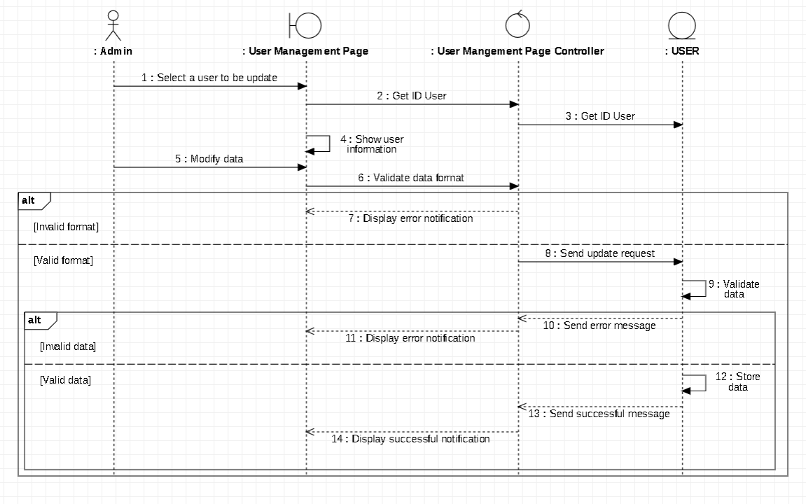

* **Class Diagram**

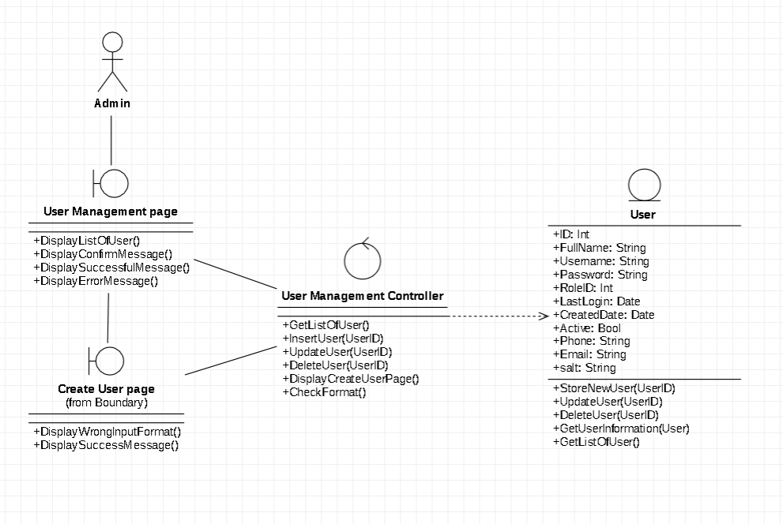

### Order management

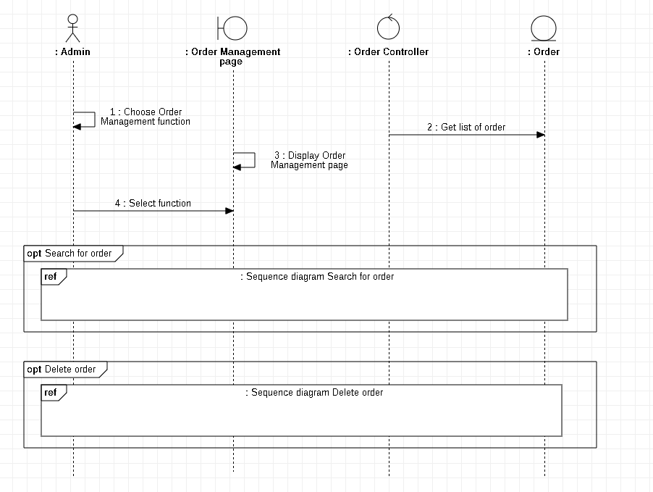

#### Search for order

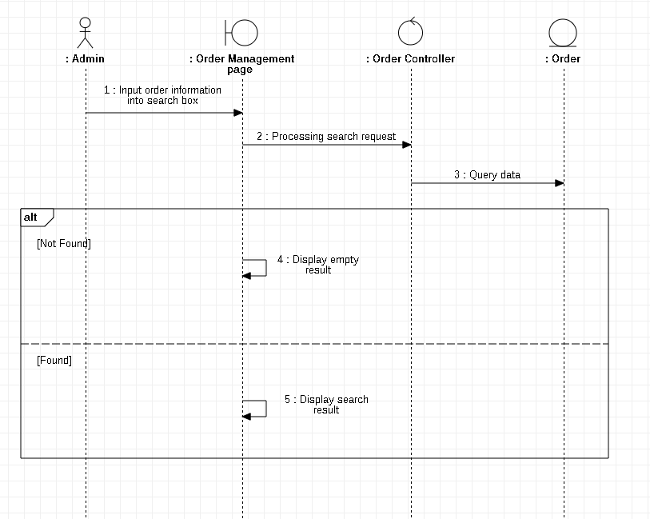

#### Delete order

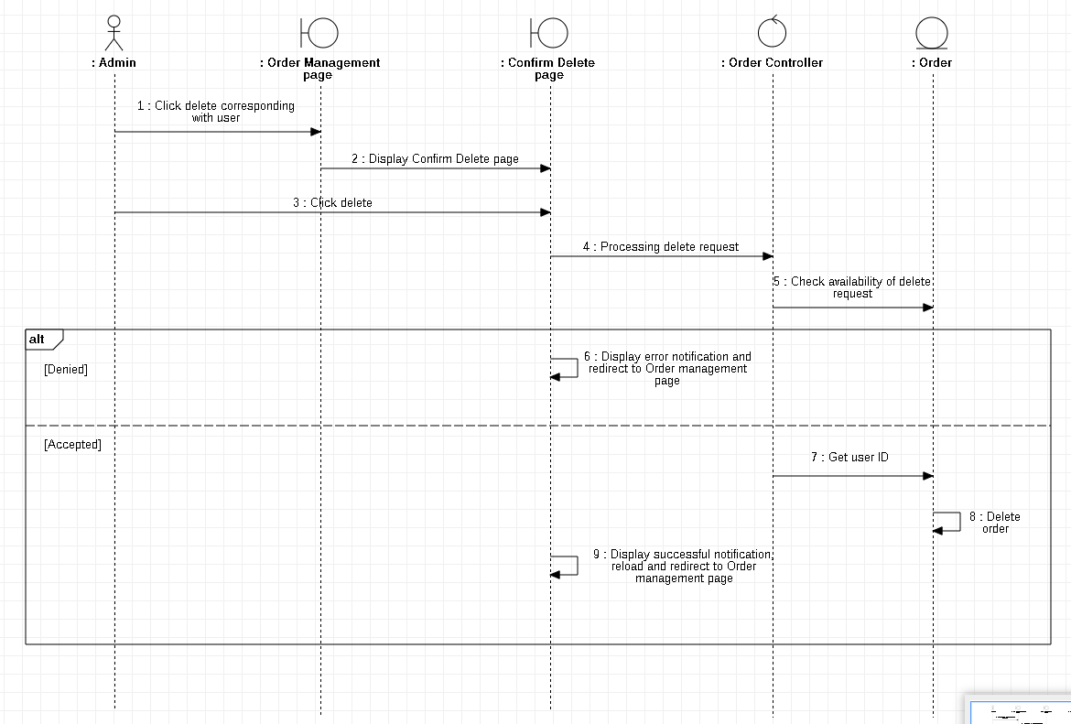

* **Class Diagram**

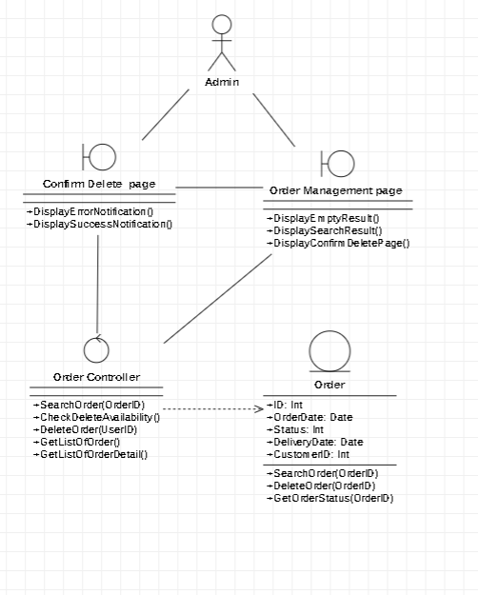

### Item management

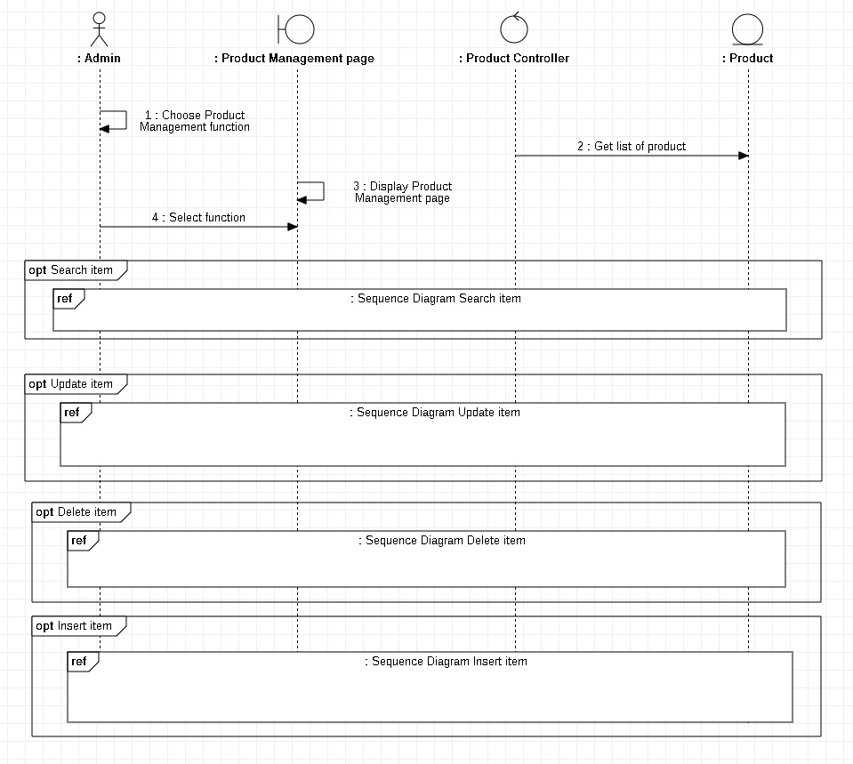

#### Insert item

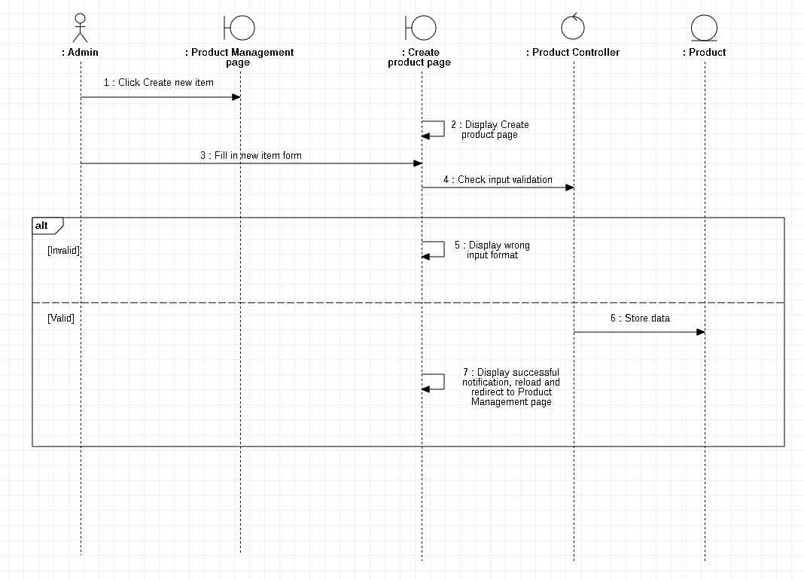

#### Update item

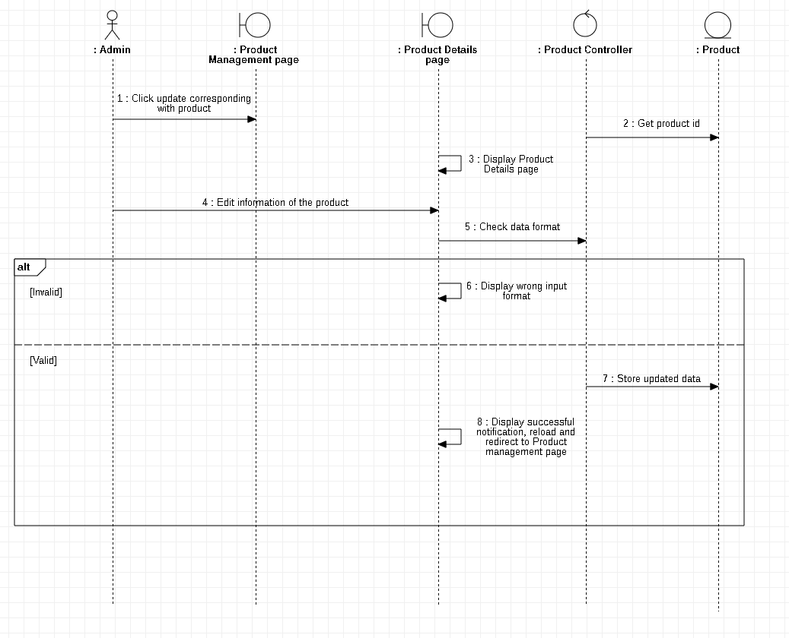

#### Delete item

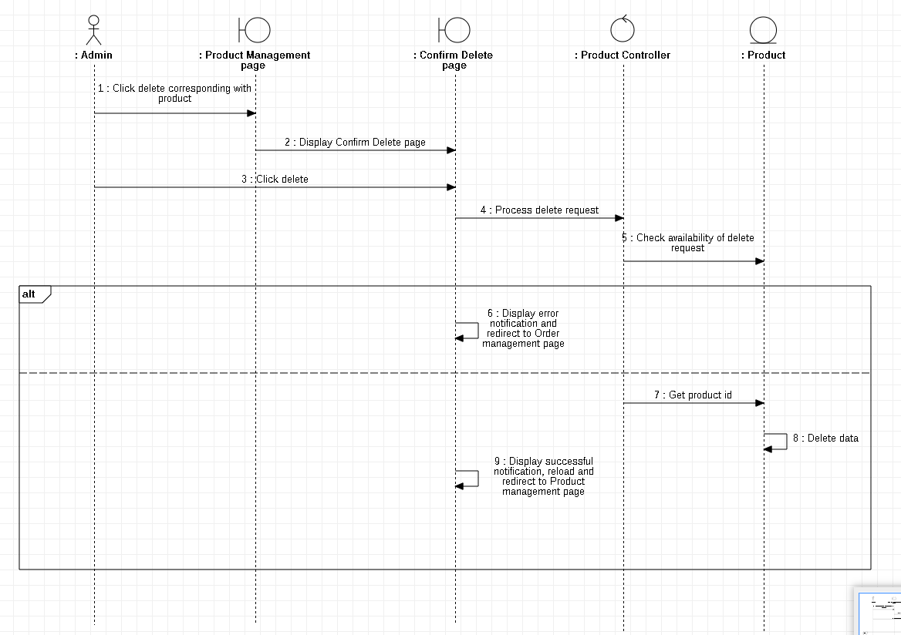

#### Search for item

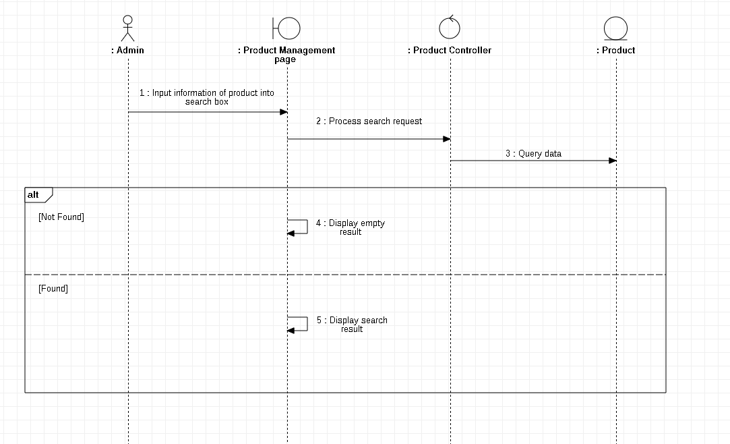

* **Class Diagram**

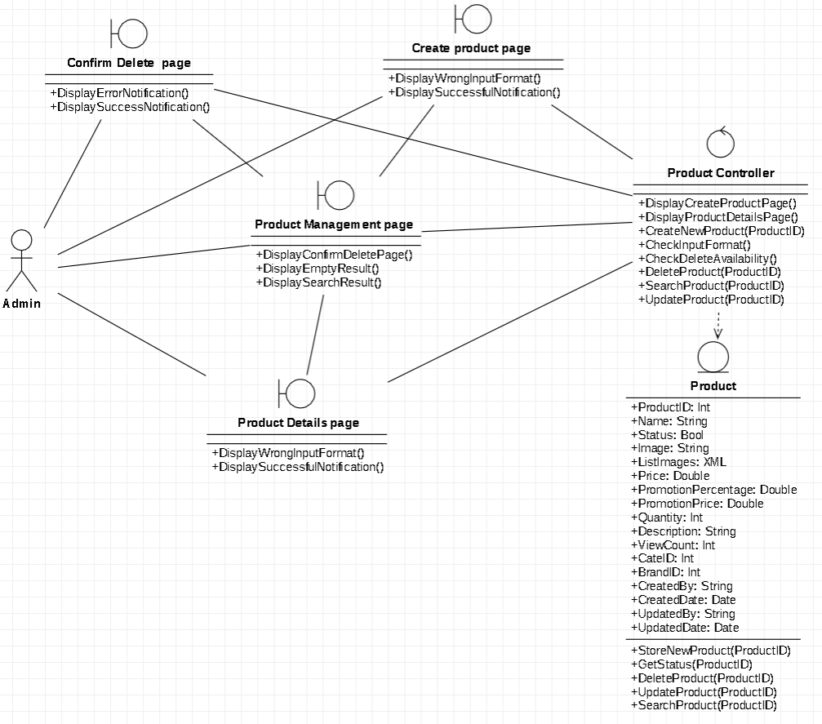

### Sales partner management

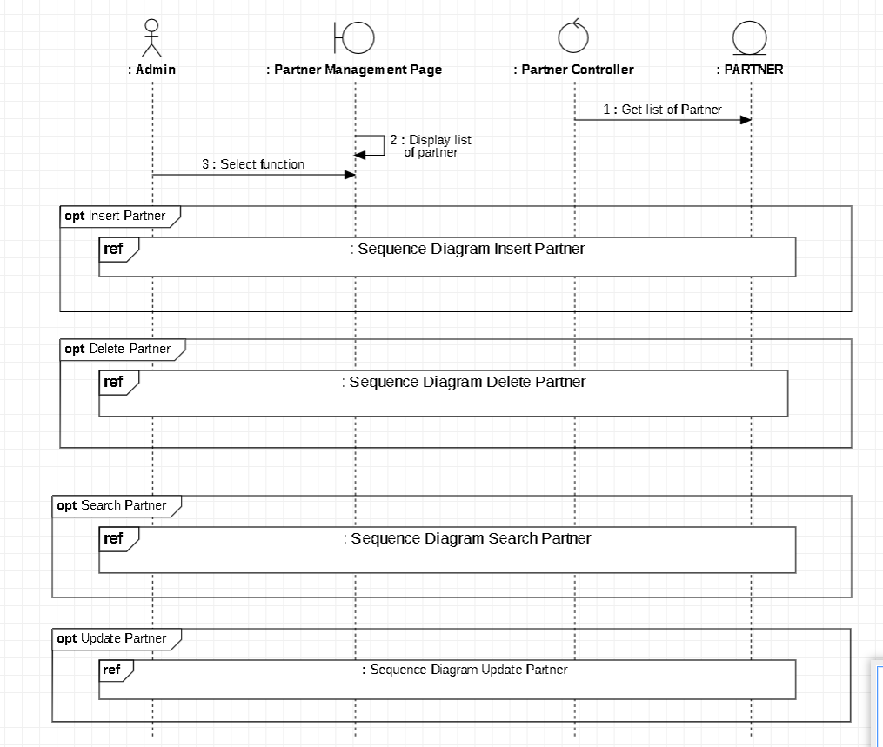

#### Insert new Sales partner

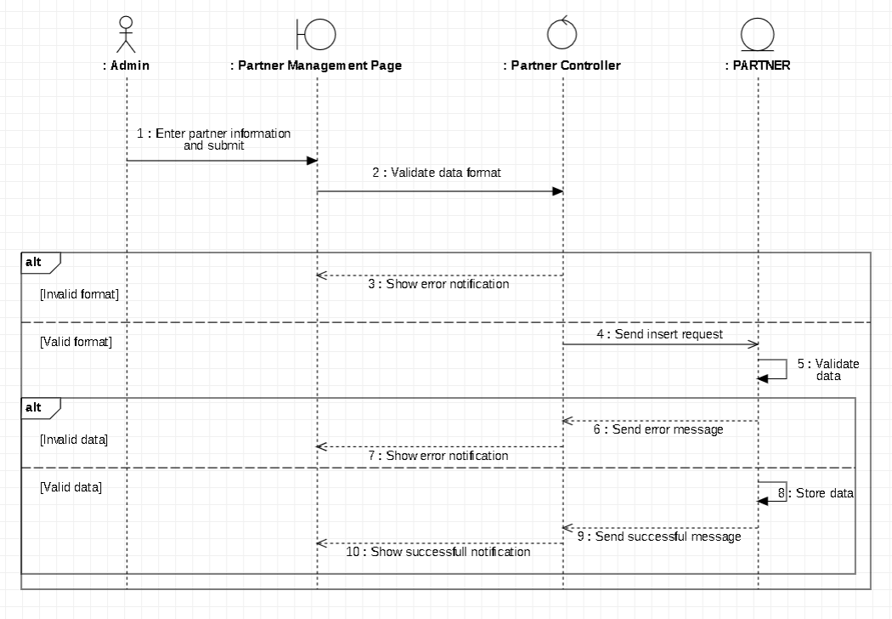

#### Update Sales partner

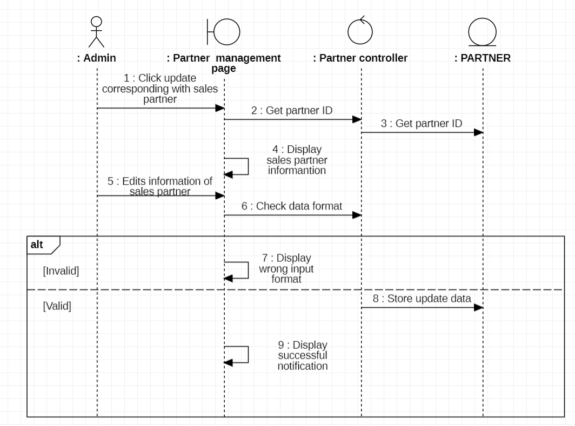

f

#### Delete Sales partner

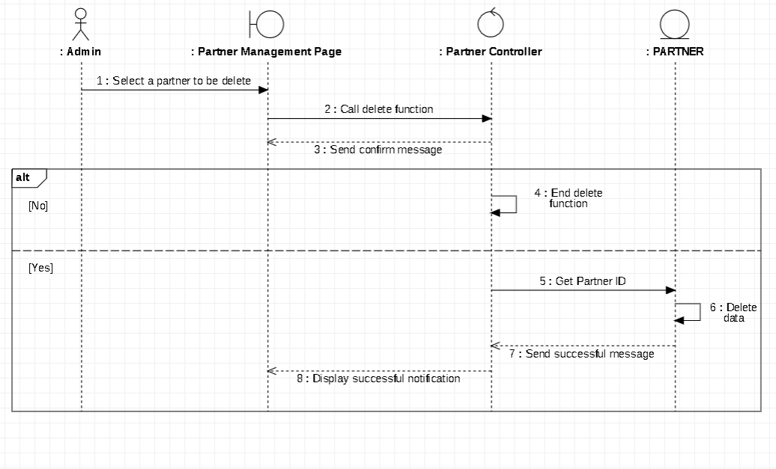

#### Search for Sales partner

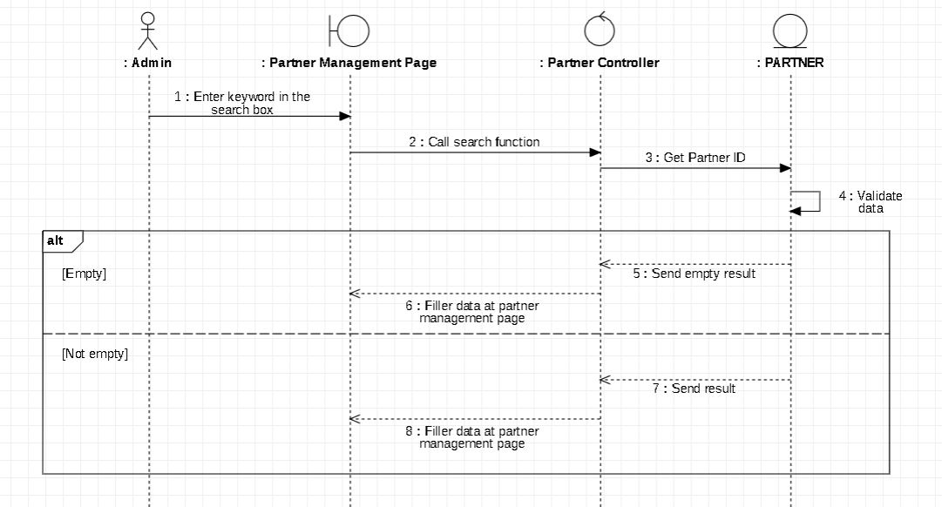

* **Class Diagram**

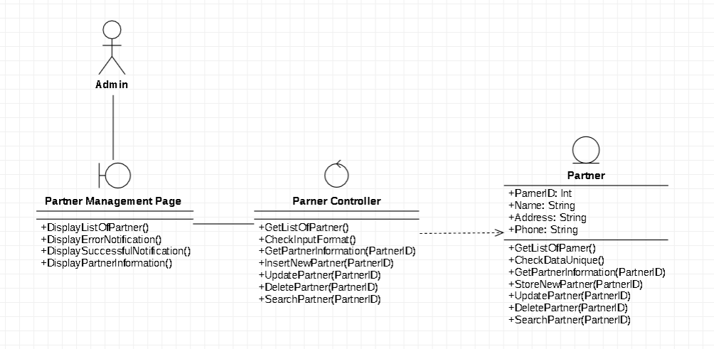

### Tracking transaction history

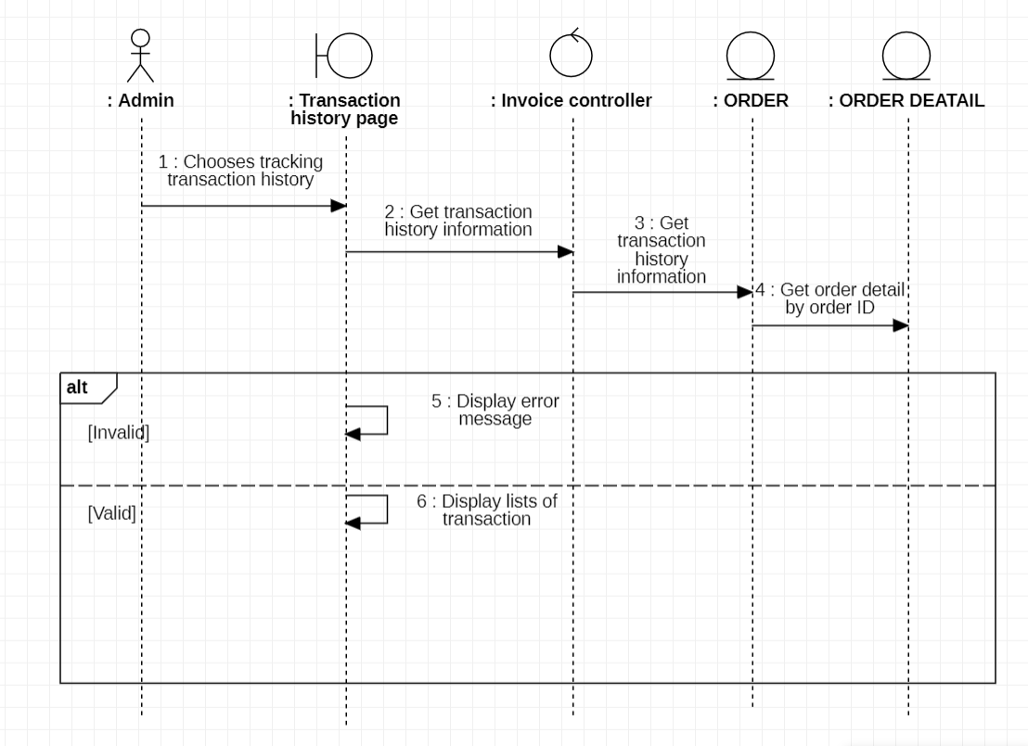

* **Class Diagram**

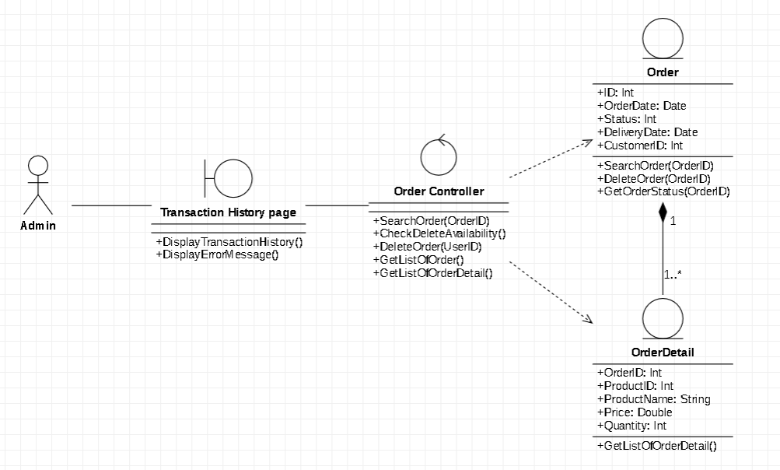

## Class diagram in general and Entity Class diagram

### User

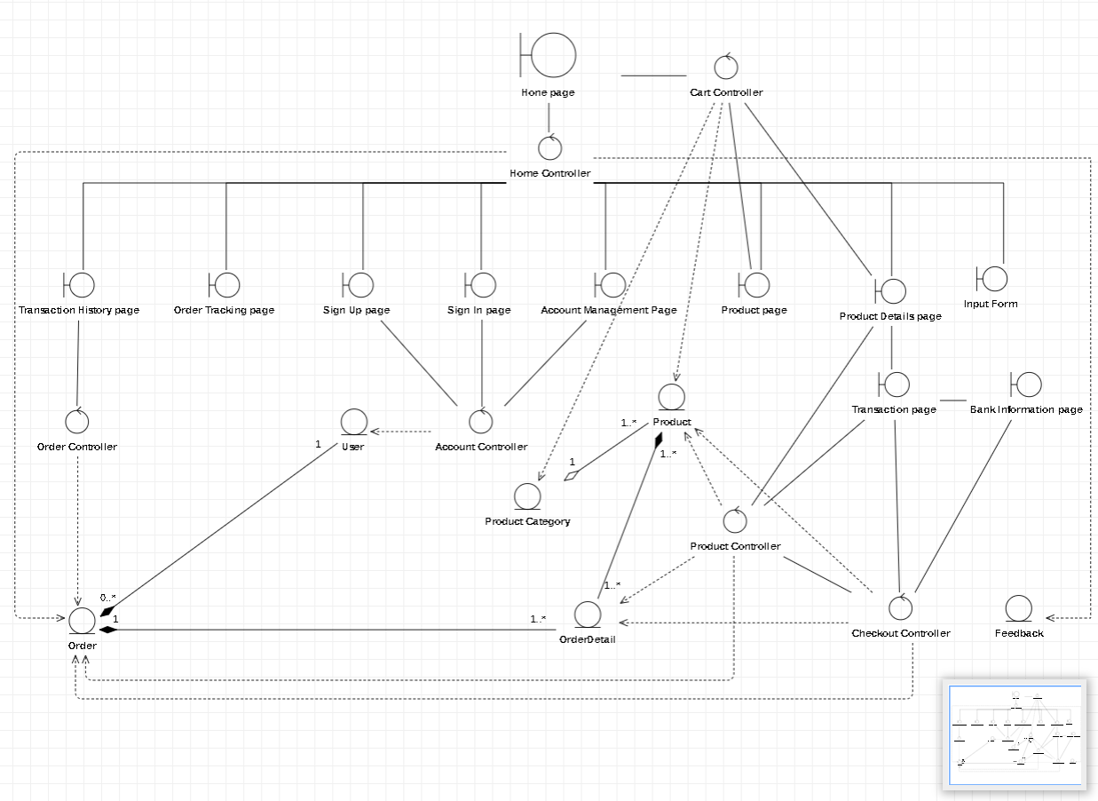

### Admin

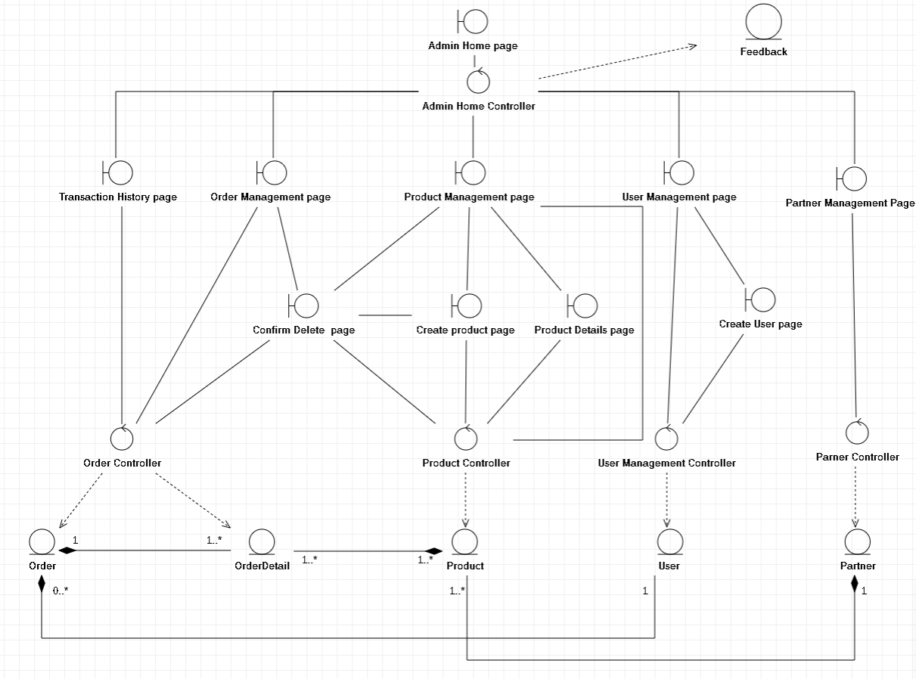

### Entity class diagram

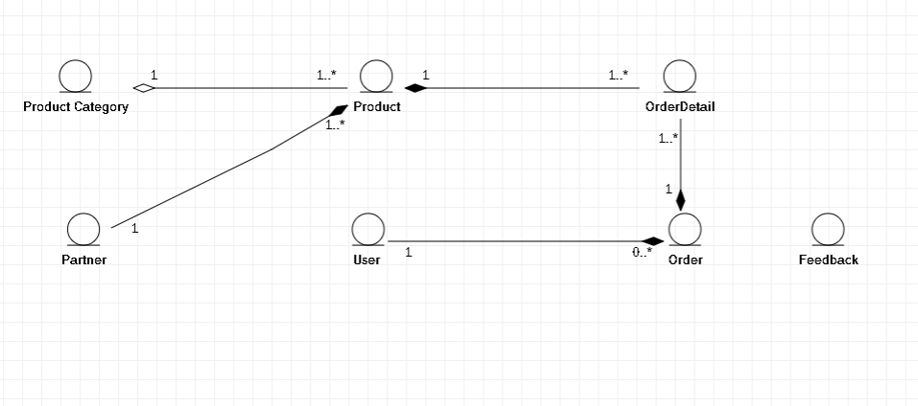

### Class diagram specification

#### User

|  |  |  |
| --- | --- | --- |
| **User** | | |
| **Attribute** | **Variable** | **Meaning** |
| ID: Int | User ID, generated by system |
| FullName: String | Full name of customer |
| Username: String | User’s account name |
| Password: String | User’s account password |
| RoleID: Int | Role of the user in system |
| LastLogin: Date | Last Login date of user |
| CreatedDate: Date | The created date of the user’s account |
| Active: Bool | The status of the user, has 2 values: 0 for offline, 1 for online |
| Phone: String | Phone of the user |
| Email: String | Email of the user |
| salt: String | A value generated by the system to create unique hash for every input |
| **Operation** | **Function** | **Meaning** |
| ValidateUserData(in Username, in Pwd) | Check if Username and Password are true or not |
| StoreSignInStatus() | Save status when user signs in |
| StoreNewUser(in UserID) | Create new user through user’s sign up, create user in admin and add to database |
| GetUserInformation(in User) | Get User information to display in Account management page |
| UpdateUserInformation(in UserID) | Update user changing information in database |
| UpdateUser(in UserID) | Update user in user management at Admin GUI |
| DeleteUser(in UserID) | Delete user in user management at Admin GUI |
| GetListOfUser() | Get list of user to display in user management at Admin GUI |

#### Order

|  |  |  |
| --- | --- | --- |
| **Order** | | |
| **Attribute** | **Variable** | **Meaning** |
| ID: Int | Order’s ID, generated by the system |
| OrderDate: Date | The date when users make their order(s) |
| Status: Int | Status of the order, has 2 states: Waiting and Finish |
| DeliveryDate: Date | The date when user receive their order(s) |
| CustomerID: Int | User’s ID, reference User’s primary key |
| **Operation** | **Function** | **Meaning** |
| CreateNewOrder() | Create new order when User make payment and store in database |
| GetTransactionHistory(UserID) | Get all order to display to user’s tracking transaction history page |
| GetStatus(UserID) | Get the status of the order to display to user’s order tracking page |
| SearchOrder(in OrderID) | Search for order in Admin’s order management page |
| DeleteOrder(in OrderID) | Delete order in Admin’s order management page |
| GetOrderStatus(in OrderID) | Get order’s status to check delete availability request in Admin’s order management page |

#### Order Detail

|  |  |  |
| --- | --- | --- |
| **OrderDetail** | | |
| **Attribute** | **Variable** | **Meaning** |
| OrderID: Int | The Order’s ID, reference Order’s primary key |
| ProductID: Int | The Product’s ID, which user buy in their order, reference Product’s primary key |
| ProductName: String | The name of the products which the user buys |
| Price: Double | Price of the product |
| Quantity: Int | Quantity of the product |
| **Operation** | **Function** | **Meaning** |
| CreateNewOrderDetails() | Create new order details when user make their order(s) |

#### Product

|  |  |  |
| --- | --- | --- |
| **Product** | | |
| **Attribute** | **Variable** | **Meaning** |
| ProductID: Int | Product’s ID, generated by system |
| Name: String | Name of the product |
| Status: Bool | Status of the Product: Out of stock or Available |
| Image: String | Image of the product |
| ListImages: XML | List images of the product |
| Price: Double | Price of the product |
| PromotionPercentage: Double | Promotion percentage of the product |
| PromotionPrice: Double | Promotion price when applys promotion percentage |
| Quantity: Int | Quantity of the product |
| Description: String | Description of the product |
| ViewCount: Int | Number of user’s view at the product |
| CateID: Int | Product’s category |
| BrandID: Int | Product’s brand |
| CreatedBy: String | Person responsibles for created this product |
| CreatedDate: Date | The created date of the product |
| UpdatedBy: String | Person responsibles for updated this product |
| UpdatedDate: Date | The updated date of the product |
| **Operation** | **Function** | **Meaning** |
| GetListOfProduct() | Get list of products to display in user’s homepage, admin’s product management page |
| CheckAvailability(in ProductID) | Check availability of the product |
| StoreNewProduct(in ProductID) | Store new Product created by admin into database |
| GetStatus(in ProductID) | Get status of the product |
| DeleteProduct(in ProductID) | Delete product in admin’s product management page |
| UpdateProduct(in ProductID) | Update product in admin’s product management page |
| SearchProduct(in ProductID) | Search product in admin’s product management page |

#### Product Category

|  |  |  |
| --- | --- | --- |
| **Product Category** | | |
| **Attribute** | **Variable** | **Meaning** |
| CateID: Int | Product’s Category ID, generated by system |
| Name: String | Name of the category |
| Status: Bool | Status of the category |
| CreatedBy: String | Person responsibles for created the category |
| CreatedDate: Date | The date when the category’d been created |
| UpdatedBy: String | Person responsibles for updated the category |
| UpdatedDate: Date | The date when the category’d been updated |
| **Operation** | **Function** | **Meaning** |
| GetListOfProductByCategory() | Get list of product category in Product mangement in admin’s product management page, user’s product page |

#### Partner

|  |  |  |
| --- | --- | --- |
| **Partner** | | |
| **Attribute** | **Variable** | **Meaning** |
| ParnerID: Int | Partner’s ID, generated by system |
| Name: String | Name of the partner |
| Address: String | Address of the partner |
| Phone: String | Phone of the partner |
| **Operation** | **Function** | **Meaning** |
| GetListOfParner() | Get list of the partner to display to partner management page |
| CheckDataUnique() | Check partner is unique in database |
| GetPartnerInformation(in PartnerID) | Get partner information for partner management page |
| StoreNewPartner(in PartnerID) | Store new partner’d been created by admin into database |
| UpdatePartner(in PartnerID) | Update partner in Admin’s partner management page |
| DeletePartner(in PartnerID) | Delete partner in Admin’s partner management page |
| SearchPartner(in PartnerID) | Search partner in Admin’s partner management page |

#### Feedback

|  |  |  |
| --- | --- | --- |
| **Feedback** | | |
| **Attribute** | **Variable** | **Meaning** |
| ID: Int | ID of the feedback, generated by the system |
| Name: String | The title of the feedback |
| Email: String | The email in which user uses to send feedback |
| Phone: String | The phone number provided by user |
| Address: String | Address provided by user |
| Detail: String | The description of the feedback, provided by user |
| **Operation** | **Function** | **Meaning** |
| StoreNewFeedback(in FeedbackID) | Create new feedback and send it to database |
| GetListOfFeedBack() | Get list of feedback to display to admin’s home page |

#### Home Controller

|  |  |  |
| --- | --- | --- |
| **Home Controller** | | |
| **Operation** | **Function** | **Meaning** |
| GetListOfOrderStatus() | Get all list of order status for user’s order tracking page |
| GetFeaturedProduct() | Get featured product to display to user’s home page |
| GetBanner() | Get all advertisement banner to display to user’s home page |
| GetListOfProduct() | Get List of products to display to user’s home page |
| CreateFeedback(in FeedbackID) | Insert feedback sent by user into database |
| DisplayInputForm() | Return to Input Form view |
| DisplayAllNotification() | Display all notification when user click on notification icon |

#### Account Controller

|  |  |  |
| --- | --- | --- |
| **Account Controller** | | |
| **Operation** | **Function** | **Meaning** |
| ValidateInputFormat() | Check input format when sign in, sign up |
| CreateNewUser() | Create new user through sign up and store to database |

#### Order Controller

|  |  |  |
| --- | --- | --- |
| **Order Controller** | | |
| **Operation** | **Function** | **Meaning** |
| SearchOrder(in OrderID) | Search order in admin’s order management page |
| CheckDeleteAvailability() | Check availability of delete request |
| DeleteOrder(in OrderID) | Delete order in order management page |
| GetListOfOrder() | Get all list of order to display to admin’s order management page |
| GetListOfOrderDetail() | Get all list of order details to display to admin’s order management page |

#### Product Controller

|  |  |  |
| --- | --- | --- |
| **Product Controller** | | |
| **Operation** | **Function** | **Meaning** |
| DisplayProductDetailsPage(in ProductID) | Redirect to user’s product details page |
| CheckAvailability(in ProductID) | Check availability of the product: out of stock or available |
| GetListOfProduct() | Get list of products to display to admin’s product management page, user’s product page |
| DisplayCreateProductPage() | Redirect to create product page |
| CheckInputFormat() | Check input format when udpate, insert product at admin’s product management page |
| CreateNewProduct(in ProductID) | Insert new product at admin’s product management page to database |
| DeleteProduct(in ProductID) | Delete product at admin’s product management page |
| UpdateProduct(in ProductID) | Update product at admin’s product management page |
| SearchProduct(in ProductID) | Search product at admin’s product management page |

#### Checkout Controller

|  |  |  |
| --- | --- | --- |
| **Checkout Controller** | | |
| **Operation** | **Function** | **Meaning** |
| DisplayTransactionPage(in Product) | Redirect to Transaction page when making order |
| GetBankingAPI() | Get banking system of other payment services |
| DisplayBankInformationPage(in Product) | Redirect to banking system when making payment |
| CreateNewOrder() | Create new order when payment successfully made |
| CreateNewOrderDetails() | Create new order details corresponding to order have just created |
| SendEmailToUser(in UserID) | Send email to user to confirm that order has been placed |

#### User Management Controller

|  |  |  |
| --- | --- | --- |
| **User Management Controller** | | |
| **Operation** | **Function** | **Meaning** |
| GetListOfUser() | Get list of users to display to admin’s user management page |
| InsertUser(in UserID) | Insert new user into database at admin’s user management page |
| UpdateUser(in UserID) | Update user into database at admin’s user management page |
| DeleteUser(in UserID) | Delete user at admin’s user management page |
| DisplayCreateUserPage() | Redirect to Create user page when admin trigger Create new user button |
| CheckFormat() | Check format validation when creating and updating user |

#### Partner Controller

|  |  |  |
| --- | --- | --- |
| **Partner Controller** | | |
| **Operation** | **Function** | **Meaning** |
| GetListOfPartner() | Get list of partners to display to admin’s partner management page |
| CheckInputFormat() | Check input format when creating or updating partner at admin’s partner management page |
| GetPartnerInformation(in PartnerID) | Get partner information when updating partner at admin’s partner management page |
| InsertNewPartner(in PartnerID) | Create new partner and store into database at admin’s partner management page |
| UpdatePartner(in PartnerID) | Update partner at admin’s partner management page and store into database |
| DeletePartner(in PartnerID) | Delete partner at admin’s partner management page |
| SearchPartner(in PartnerID) | Search partner at admin’s partner management page |

#### Admin Home Controller

|  |  |  |
| --- | --- | --- |
| **Admin Home Controller** | | |
| **Operation** | **Function** | **Meaning** |
| GetListOfFeedback() | Get all list of feedback store in database |
| SendFeedbackReplyByEmail(in FeedbackID, in UserID) | Send Feedback Reply to user email |

#### Transaction History Boundary

|  |  |  |
| --- | --- | --- |
| **Transaction History Boundary** | | |
| **Operation** | **Function** | **Meaning** |
| DisplayTransactionHistory() | Display all transaction history get from database to view |

#### Order Tracking Boundary

|  |  |  |
| --- | --- | --- |
| **Order Tracking Boundary** | | |
| **Operation** | **Function** | **Meaning** |
| DisplayListOfOrderStatus() | Display all order status data get from database to view |

#### Sign Up Boundary

|  |  |  |
| --- | --- | --- |
| **Sign Up Boundary** | | |
| **Operation** | **Function** | **Meaning** |
| DisplayWrongInputFormat() | Display wrong input format dialog |
| DisplayErrorMessage() | Display Error dialogwhen system gets error |
| DisplaySuccessfulMessage() | Display Sign up success dialog |

#### Sign In Boundary

|  |  |  |
| --- | --- | --- |
| **Sign In Boundary** | | |
| **Operation** | **Function** | **Meaning** |
| DisplayWrongInputFormat() | Display wrong input format dialog |
| DisplayErrorMessage() | Display Error dialog when system gets error |
| DisplaySuccessfulMessage() | Display Sign in success dialog |

#### Account Management Boundary

|  |  |  |
| --- | --- | --- |
| **Account Management Boundary** | | |
| **Operation** | **Function** | **Meaning** |
| DisplayUserInformation() | Display User Information to Account Management page |
| DisplayErrorMessage() () | Display Error message when system gets error |
| DisplaySuccessMessage() | Display Success dialog when the action of user was modified successfully |

#### Product Boundnary

|  |  |  |
| --- | --- | --- |
| **Product Boundnary** | | |
| **Operation** | **Function** | **Meaning** |
| DisplayListOfProduct() | Display list of product to user’s home page and product page, admin’s product management |
| DisplayOutOfStockMessage() | Display out of stock dialog when product is not enough for selling |
| DisplaySuccessfulNotification() | Display Success dialog when the action of admin was modified successfully |
| ShowConfirmDeleteMessage() | Display Confirm dialog when admin wants to delete the product |

#### Product Details Boundary

|  |  |  |
| --- | --- | --- |
| **Product Details Boundary** | | |
| **Operation** | **Function** | **Meaning** |
| DisplayWrongInputFormat() | Display Wrong input format dialog |
| DisplaySuccessfulNotification() | Display Success dialog when the action of admin was modified successfully |

#### Input Form Boundary

|  |  |  |
| --- | --- | --- |
| **Input Form Boundary** | | |
| **Operation** | **Function** | **Meaning** |
| SendFeedbackToController() | Send feedback form to Home Controller |

#### Transaction Boundary

|  |  |  |
| --- | --- | --- |
| **Transaction Boundary** | | |
| **Operation** | **Function** | **Meaning** |
| DisplayConfirmPaymentMessage() | Display confirms to pay dialog |
| DisplayCartSession() | Display product in cart of user’s session |
| DisplayOrderSuccessfulMessage() | Display order successful dialog |

#### Bank Information Boundary

|  |  |  |
| --- | --- | --- |
| **Bank Information Boundary** | | |
| **Operation** | **Function** | **Meaning** |
| DisplayErrorMessage() | Display Error dialog when banking service was error |
| CheckBalance() | Check balance of the bank account |
| MakePayment() | Make payment through banking service |

#### Order Management Boundary

|  |  |  |
| --- | --- | --- |
| **Order Management Boundary** | | |
| **Operation** | **Function** | **Meaning** |
| DisplayEmptyResult() | Display empty result when no searching found |
| DisplaySearchResult() | Display search result in admin’s order management |
| DisplayConfirmDeletePage() | Redirect to confirm delete page when admin performs delete action |

#### Product Management Boundary

|  |  |  |
| --- | --- | --- |
| **Product Management Boundary** | | |
| **Operation** | **Function** | **Meaning** |
| DisplayConfirmDeletePage() | Redirect to delete confirmation page |
| DisplayEmptyResult() | Display empty result in product management page |
| DisplaySearchResult() | Display search result in product management page |

#### User Management Boundary

|  |  |  |
| --- | --- | --- |
| **User Management Boundary** | | |
| **Operation** | **Function** | **Meaning** |
| DisplayListOfUser() | Display list of users in user management page |
| DisplayConfirmMessage() | Display confirm dialog when deleting user |
| DisplaySuccessfulMessage() | Display successful dialog when create, update, or delete user successfully |
| DisplayErrorMessage() | Display error message when system was crashing |

#### Partner Management Boundary

|  |  |  |
| --- | --- | --- |
| **Partner Management Boundary** | | |
| **Operation** | **Function** | **Meaning** |
| DisplayListOfPartner() | Display list of partnerin partner management page |
| DisplayErrorNotification() | Display error notification when system error in create, update, delete partner |
| DisplaySuccessfulNotification() | Display successful dialog when updating, creating or deleting successfully |
| DisplayPartnerInformation() | Display information of partner in partner management page |

#### Confirm Delete Boundary

|  |  |  |
| --- | --- | --- |
| **Confirm Delete Boundary** | | |
| **Operation** | **Function** | **Meaning** |
| DisplayErrorNotification() | Display error when delete unsuccessfully |
| DisplaySuccessNotification() | Display success dialog when delete successfully |

#### Create Product Boundary

|  |  |  |
| --- | --- | --- |
| **Create Product Boundary** | | |
| **Operation** | **Function** | **Meaning** |
| DisplayWrongInputFormat() | Display wrong input format if admin inputs wrong format |
| DisplaySuccessfulNotification() | Display successful dialog if creating product successfully |

#### Create User Boundary

|  |  |  |
| --- | --- | --- |
| **Create User Boundary** | | |
| **Operation** | **Function** | **Meaning** |
| DisplayWrongInputFormat() | Display wrong input format if admin inputs wrong information |
| DisplaySuccessMessage() | Display success dialog if create user successfully |

#### Home Boundary

|  |  |  |
| --- | --- | --- |
| **Home Boundary** | | |
| **Operation** | **Function** | **Meaning** |
| DisplayListOfProduct() | Display list of products in user’s home page |
| InsertToCart() | Insert product to cart using session |
| DisplayFeedbackReplyMessage() | Display feedback reply message to user |

#### Admin Home Boundary

|  |  |  |
| --- | --- | --- |
| **Admin Home Boundary** | | |
| **Operation** | **Function** | **Meaning** |
| DisplayListOfFeedback() | Display list of feedback in Admin’s home page |
| ReplyToFeedback() | Reply to user’s feedback and send it to Admin Home Controller |

## State diagram

### Account

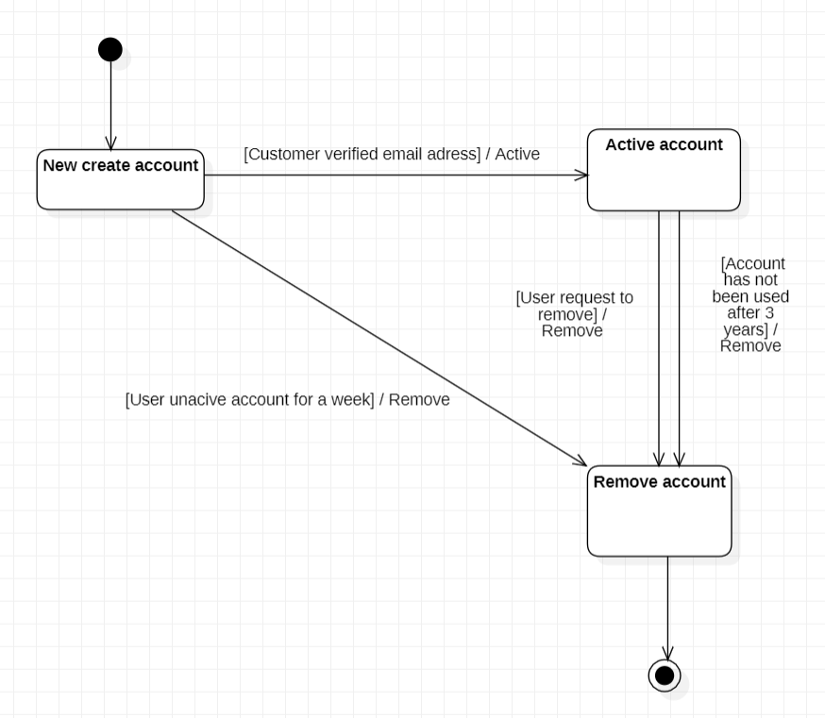

### Product

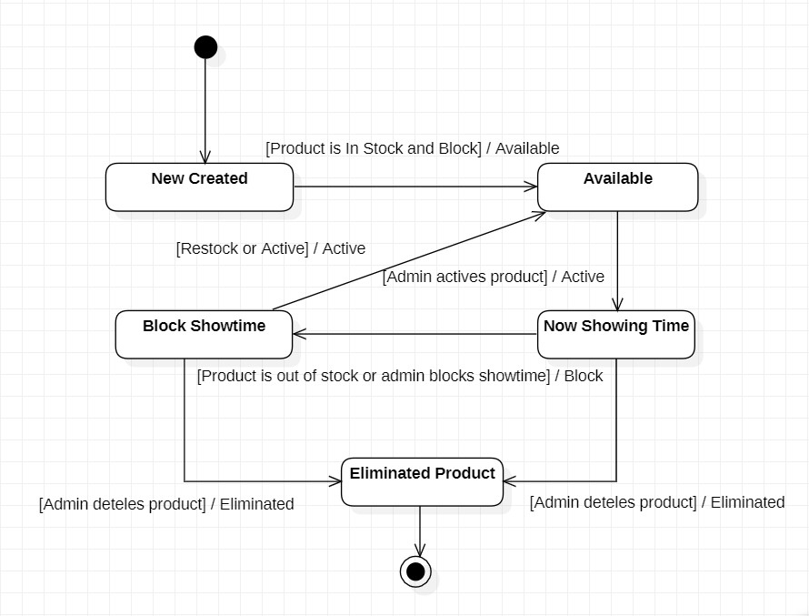

### Order tracking

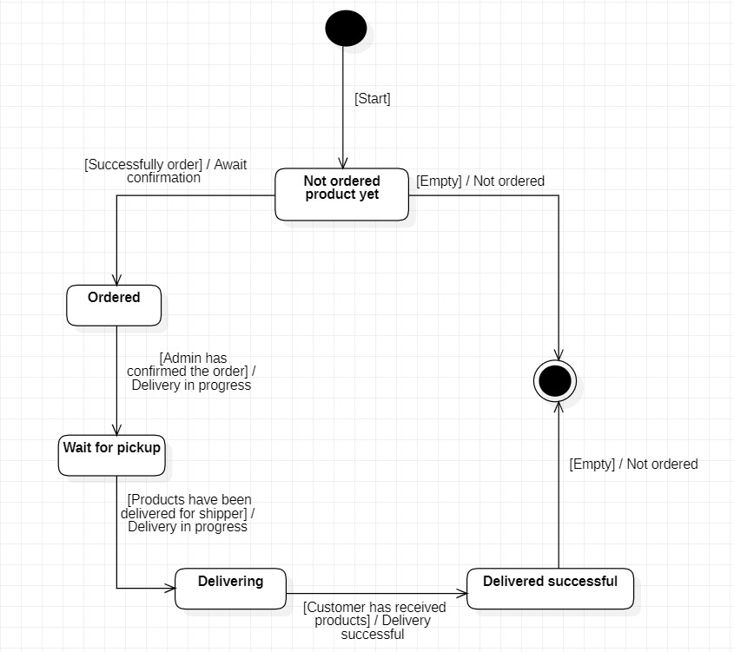

## Mapping to Relational Model diagram from Entity class diagram

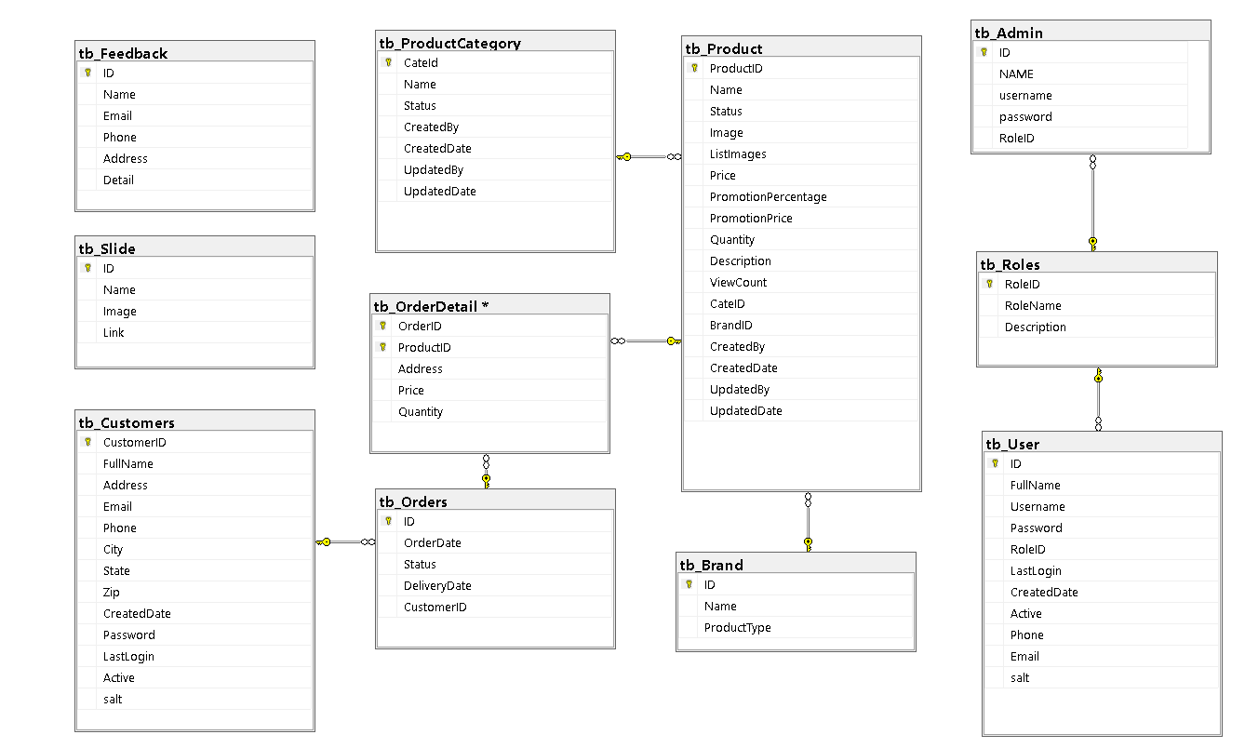

# Implementation and Testing

## Introduction to the implementation environment

### Development environment

* Operating system: Window 10
* Database: Microsoft sql server database
* Text Editor: Visual Studio Code
* Framework: ASP.NET CORE MVC
* Web GUI: HTML, CSS
* Dependencies package: Bootswatch theme, fontawesome, Microsoft.EntityFrameworkCore, Microsoft.AspNetCore. Mvc.Razor. RuntimeCompilation, …

### Deployment environment

* Operating system: Window 10 or upper
* Browser: Google Chorme, Mozilla Firefox, Microsoft edge, Opera, ...

## User Interface

### User

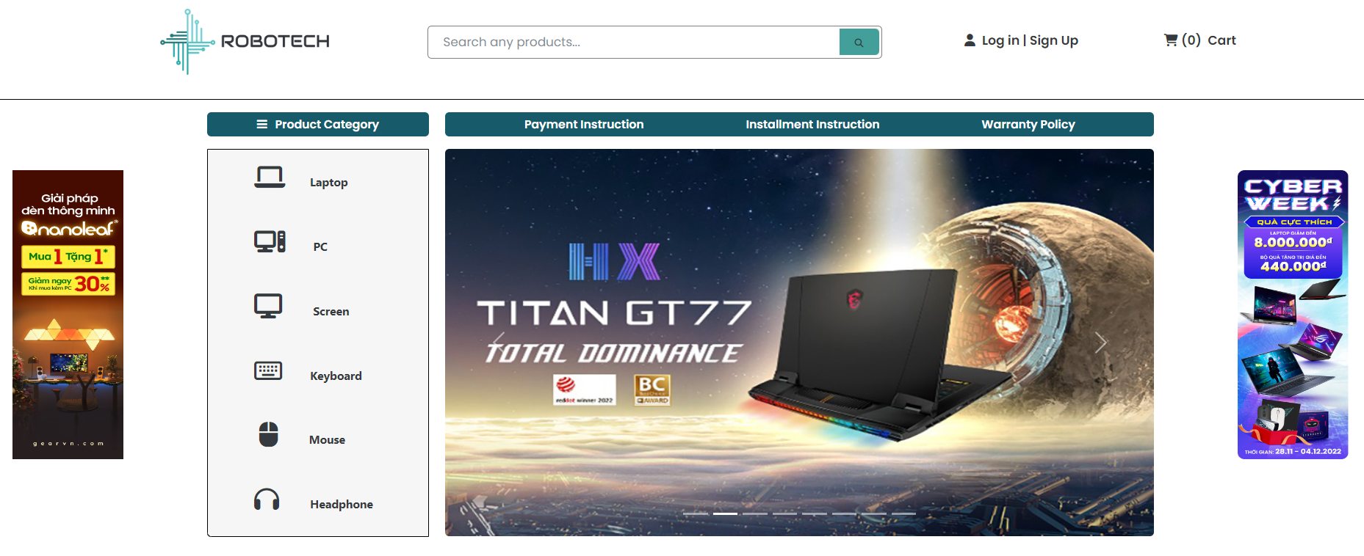

**Picture 1. Homepage**

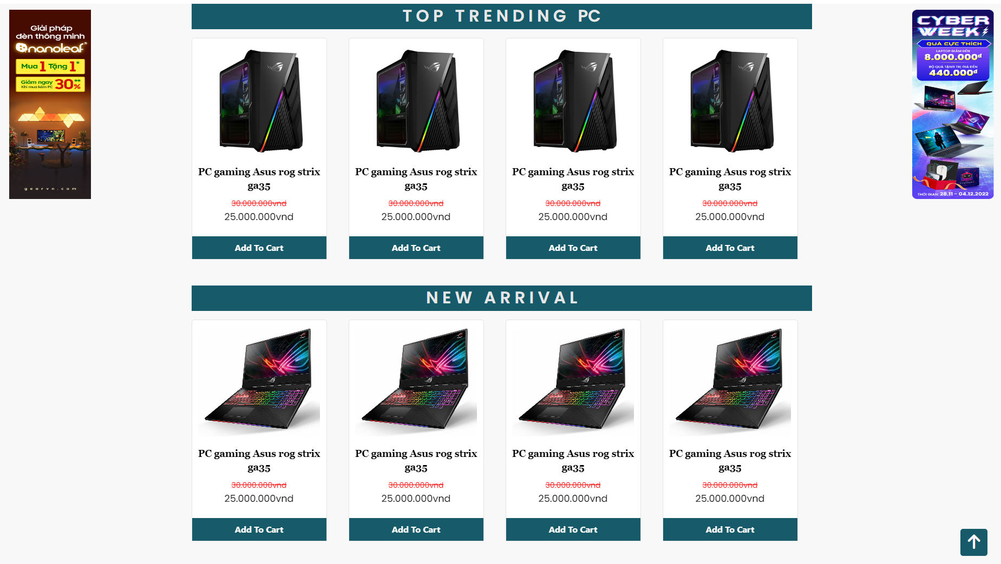

**Picture 2. Top Trending PC and New Arrival**

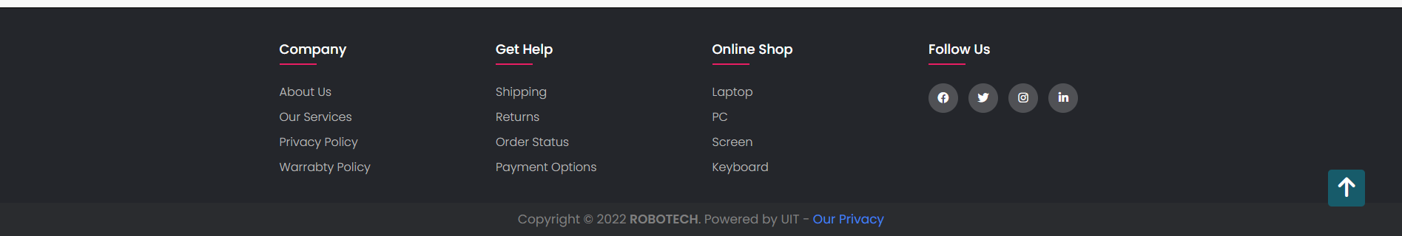

**Picture 3. Footer**

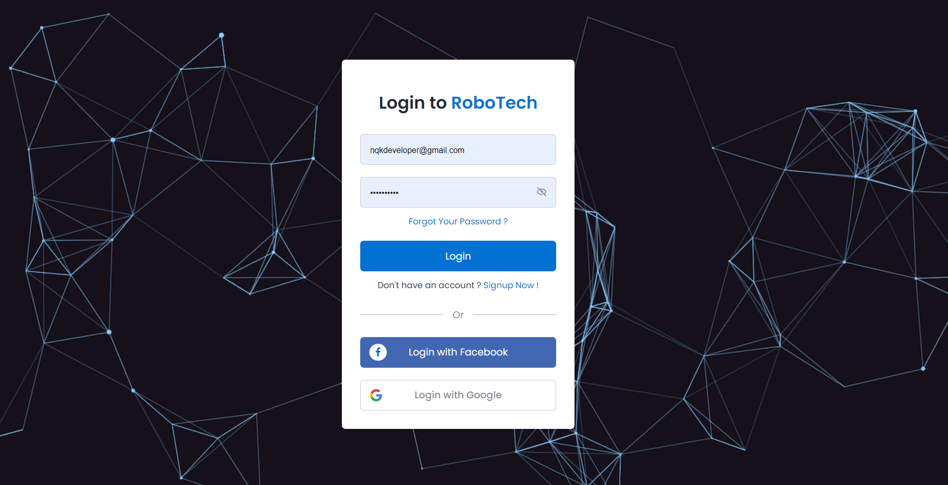

**Picture 4. Login**

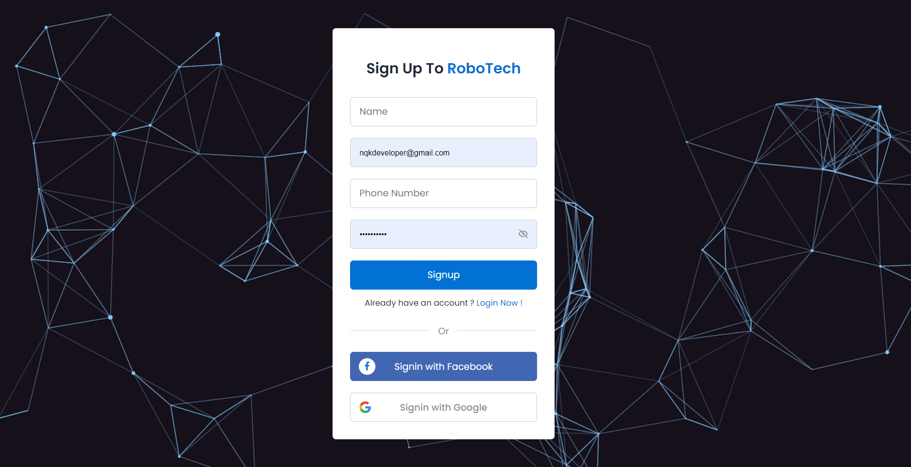

**Picture 5. Sign Up**

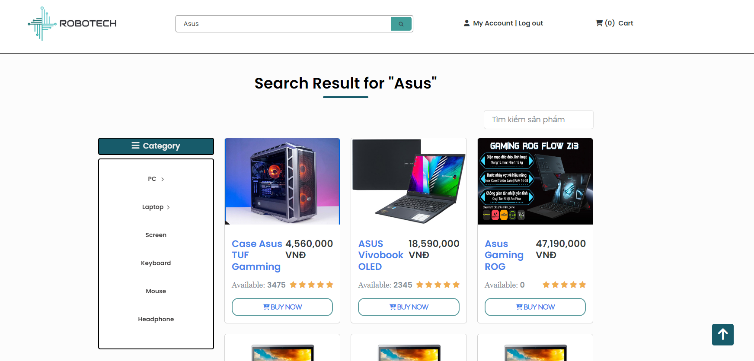

**Picture 6. Search Product**

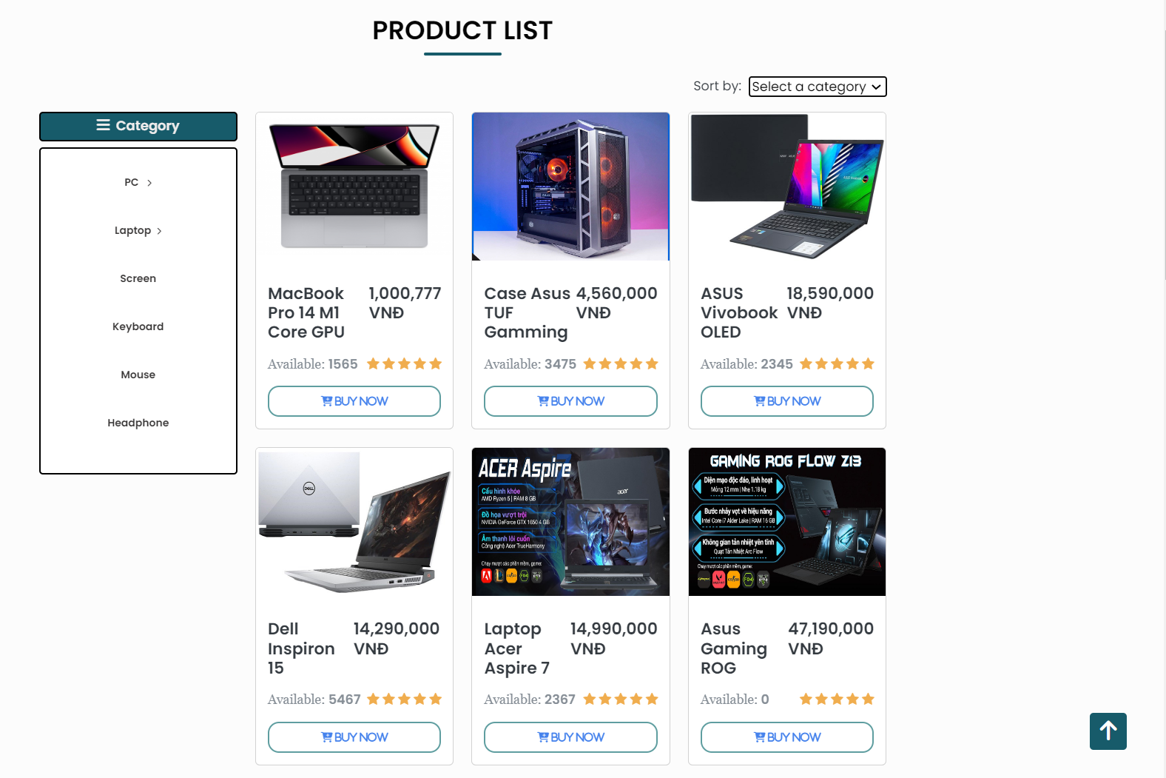

**Picture 7. Product**

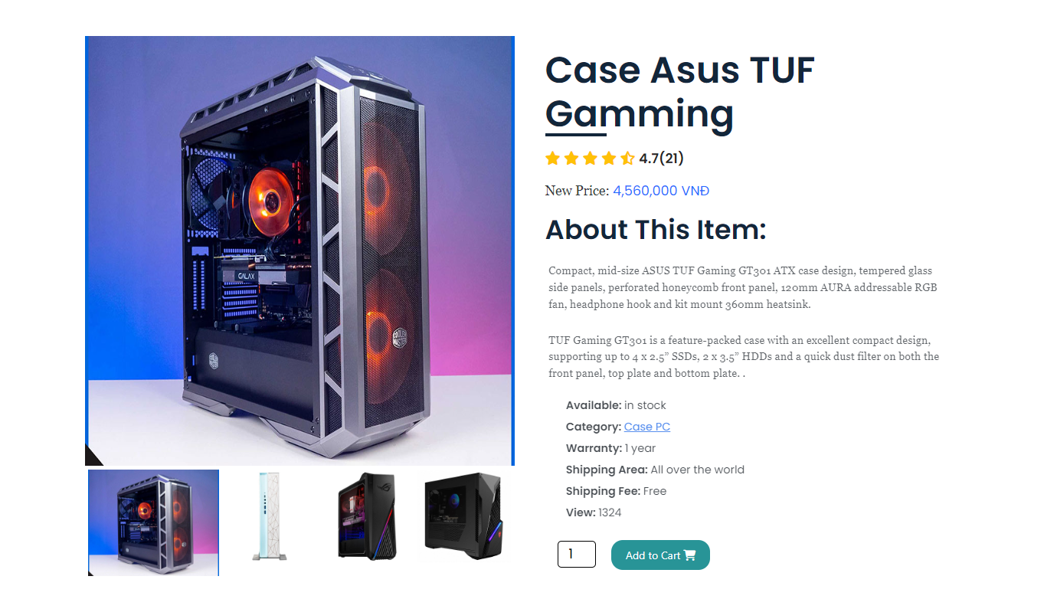

**Picture 8. Product Details Page**

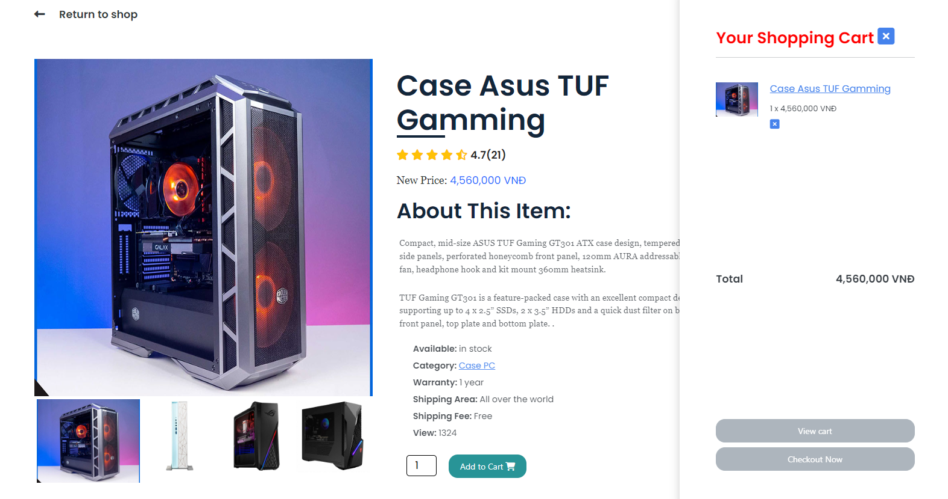

**Picture 9. Cart Partial View**

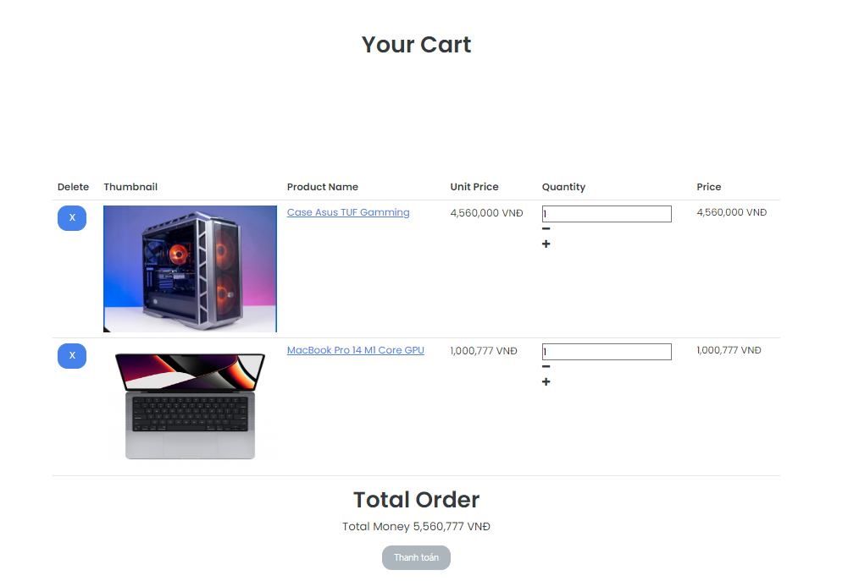

**Picture 10. Cart**

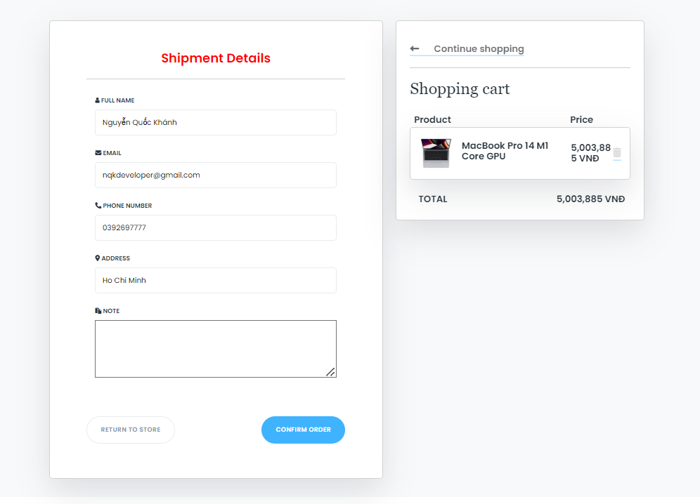

**Picture 11.Checkout**

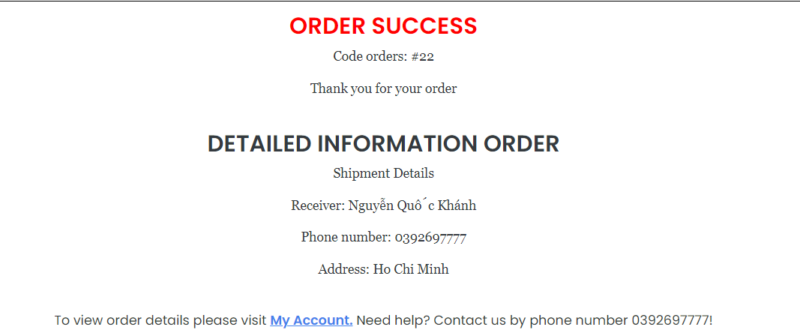

**Picture 12. Order Review**

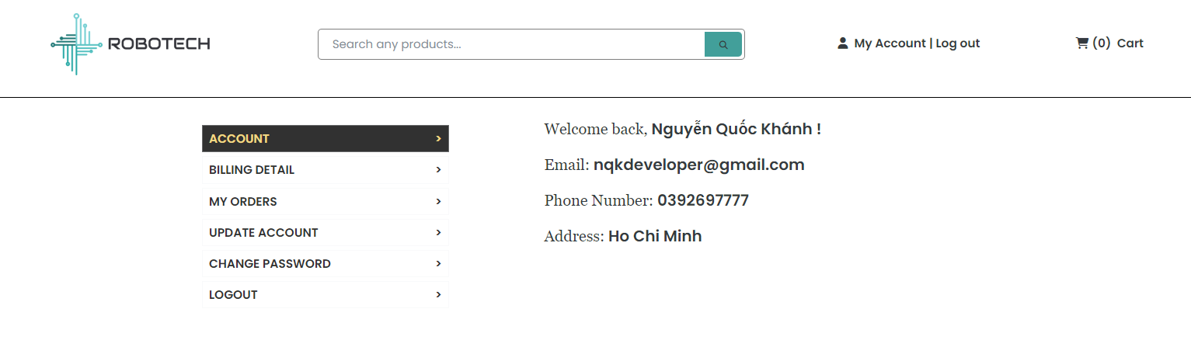

**Picture 13. Account Management**

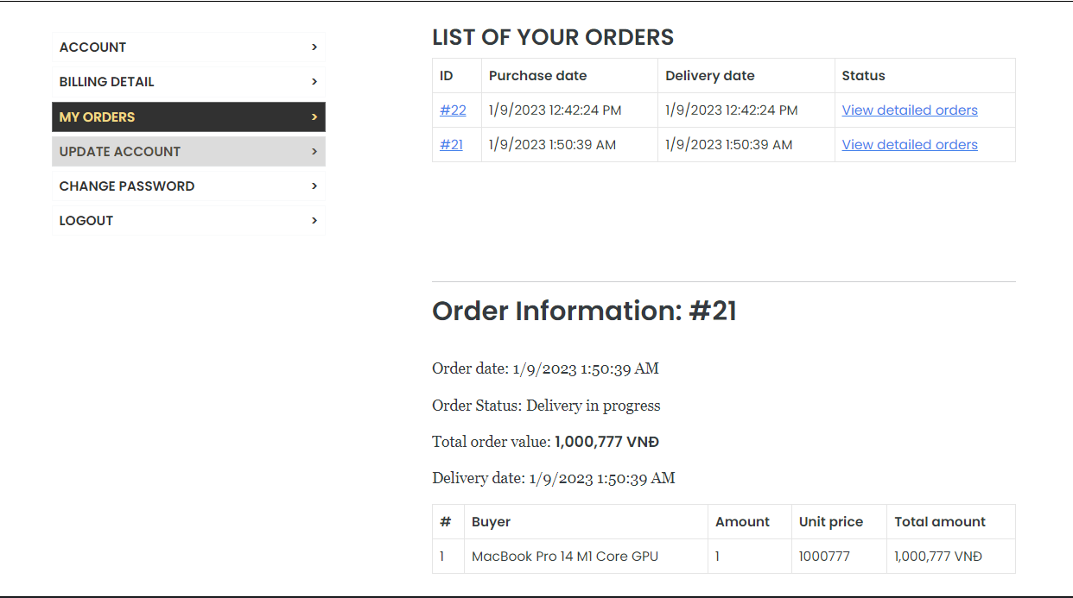

**Picture 14. Order Tracking**

### Admin

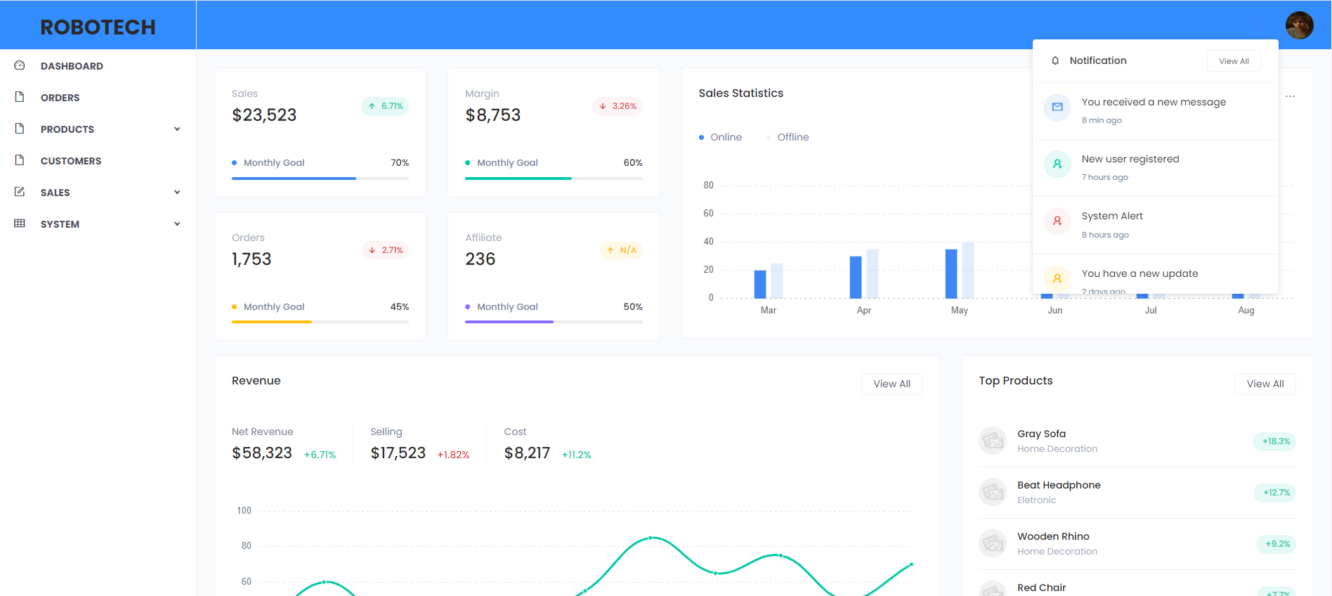

**Picture 15. Admin Home**

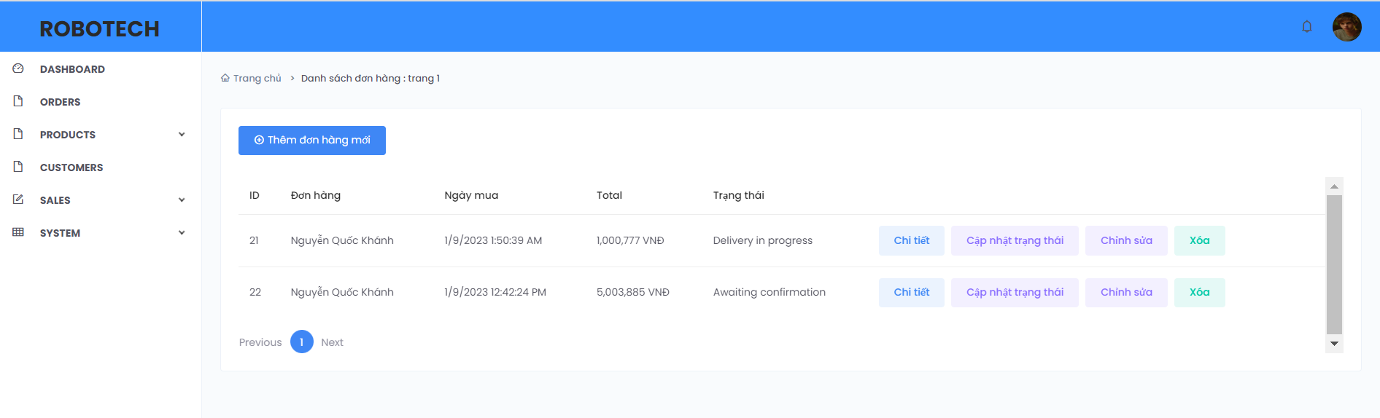

**Picture 16. Order Management**

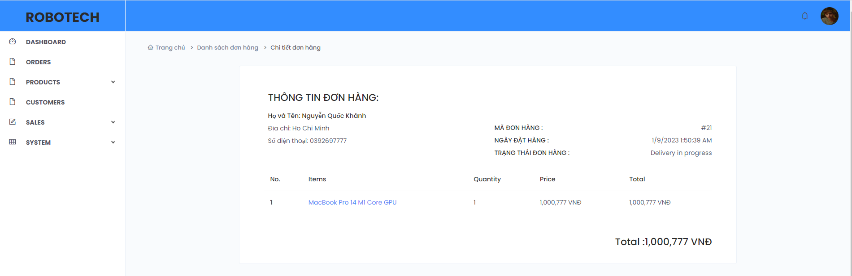

**Picture 17 Order Details**

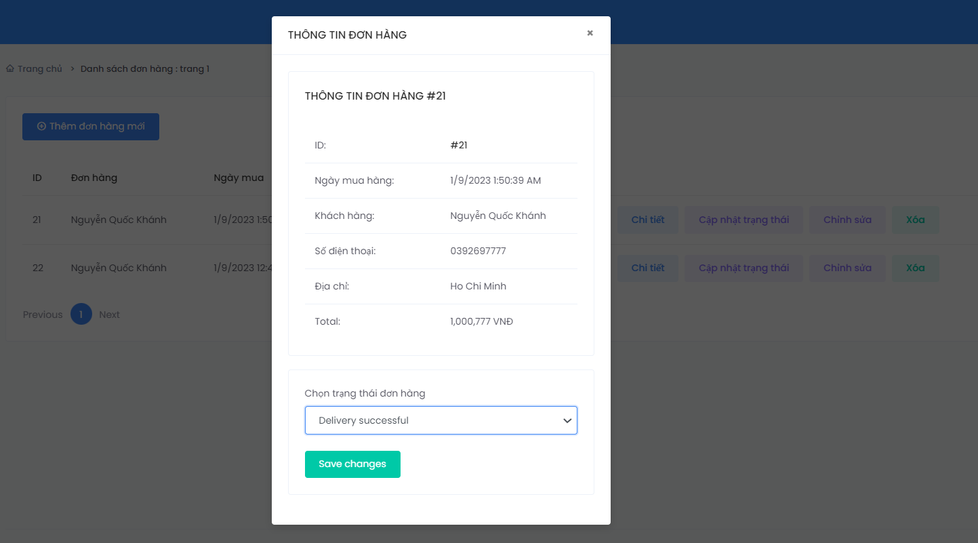

**Picture 18. Update Order Status**

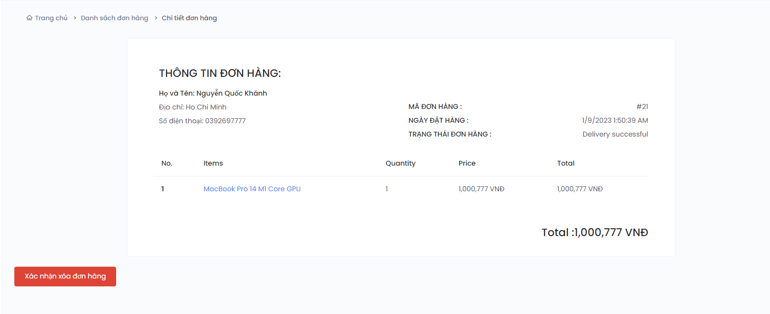

**Picture 19. Delete Order**

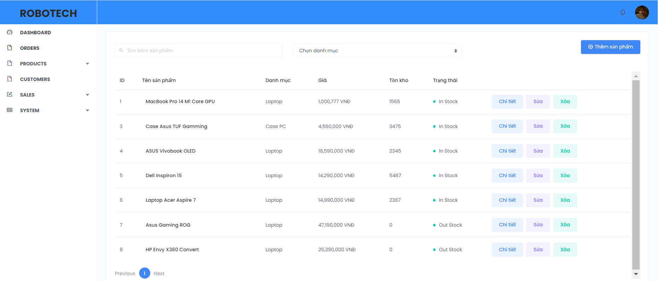

**Picture 20. Product Management**

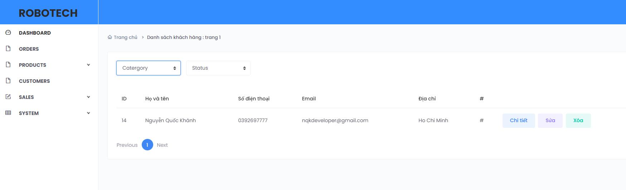

**Picture 21. Customer Management**

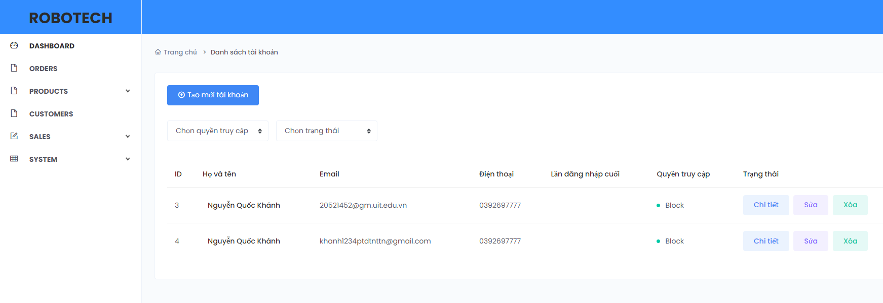

**Picture 22. Account Management**

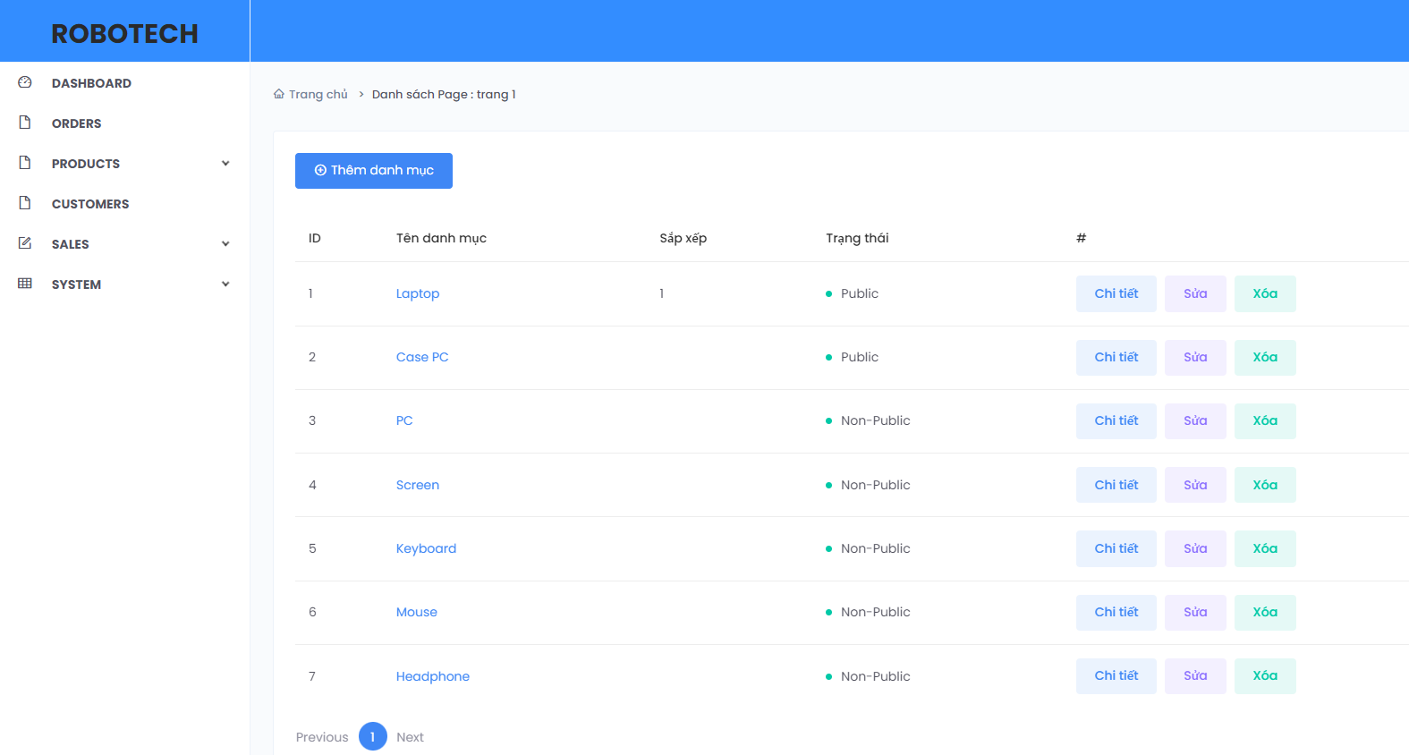

**Picture 23. Product Category Management**

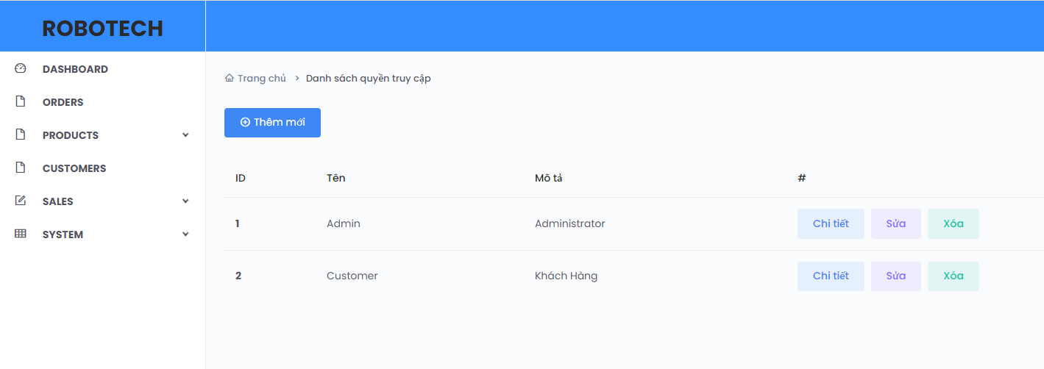

**Picture 24. Role Management**

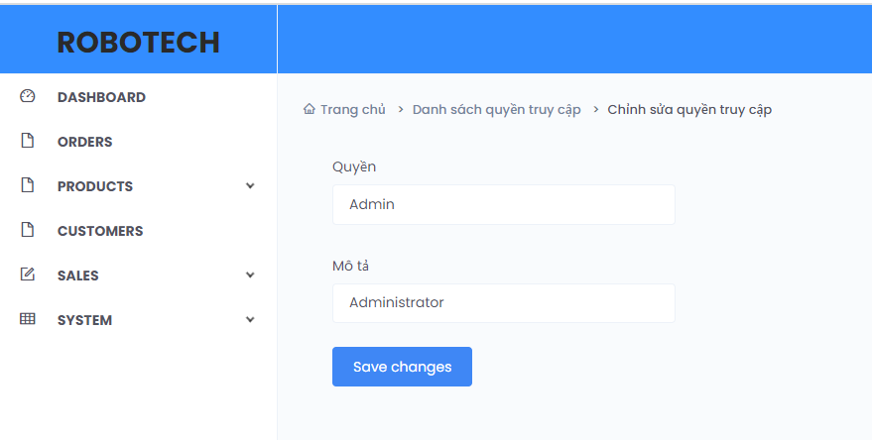

**Picture 25. Update Role**